SMALL AND MEDIUM-SIZED BUSINESS DEVELOPMENT TRENDS IN CRISIS CONDITIONS: MODERN CHALLENGES AND PROSPECTS
Abstract
The aim of this study is that the role of small and medium-sized businesses in the economic life of society is very important: it contributes to economic growth in the country, raises the level of employment, creates healthy competition, promotes the development of innovations, and solves many social problems.
Many Georgian or International organizations regularly publish their research, but there is still much to investigate and learn more about small and medium-sized business development trends in crisis conditions.
The article analyzes the development trends of small and medium businesses in Georgia in conditions of external shocks. The analysis of the dynamics of small and medium business development indicators in the country in 2017-2022 is presented.
it is of great importance that small and medium-sized businesses fully absorb the support and incentive programs planned in Georgia and use the significant opportunities that these programs create, as a result of which the country's economic growth and development will be accelerated, the living standards of the population will rise, and the country's competitiveness will increase.

Key words: small and medium entrepreneurship, competition, development, economy

JEL Classification: G21, G28, O16

Introduction
It is impossible to achieve a high level of competitiveness in the country without ensuring the effective operation of small and medium-sized businesses, which represent one of the mass sectors of the economy in many countries of the world and contribute to the creation of a significant number of jobs. Small and medium-sized businesses, in the conditions of today's high level of uncertainty and turbulence of the external environment, respond quickly to changes in market conditions, which contributes to the rapid adaptation and restructuring of the national economy in crisis conditions. The development of the small business sector and maintaining a high level of competition is the main step in ensuring the sustainable and predictable development of the national economy.
A unique characteristic and advantage of small and medium-sized enterprises is their mobility and high speed of response to changing market conditions. However, these characteristics of small and medium-sized businesses can also be a weakness for companies in times of economic crisis, leading to a sharp drop in consumer demand.
The purpose of the article is to assess the performance of small and medium-sized enterprises in crisis conditions, to analyze state support measures, and also to substantiate the possibility of using international experience in supporting small businesses in crisis situations. The topicality of the topic is due to the sharply increased pressure on small businesses in Georgia in the world, especially due to the ongoing processes in the region, as a result of which the risk of bankruptcy of small enterprises and leaving the market has increased.
The scientific novelty of the article lies in the fact that we investigated the main challenges of small and medium-sized businesses in Georgia and determined the support mechanisms not only in relation to the specific circumstances of the economic situation in the conditions of reduced demand and limited economic activity during the pandemic but also in relation to the existing needs of small and medium-sized businesses, which were aggravated in the crisis situation.
The working hypothesis can be formulated by using the results of the analysis of positive national and international experiences in the implementation of measures to support small and medium enterprises in crisis conditions, in this regard, defining challenges and setting perspectives.

Literature review
The development trends of small and medium businesses under the crisis conditions have been discussed in his works by such governmental organizations as the Committee of Sectoral Economy and Economic Policy of the Parliament of Georgia, the Ministry of Economy and Sustainable Development of Georgia, as well as non-governmental organizations working in this field. And on an international scale, in this regard, such organizations regularly publish their research, for example, the Center for Entrepreneurship, Small and Medium Business and Local Development of the Organization for Economic Cooperation and Development (OECD); United Nations Conference on Trade and Development (UNCTAD) and World Economic Forum (WEF).
In this regard, recent works of such scientists as Celine Kauffmann's work From One Crisis to Another: What Price for SMES?; John Woo Paper 5 Key Trends Small Businesses Should Jump On In 2022; Diaan-Yi Lin and Karim Tadjeddine's Beyond Financials: Helping Small and Medium-size Enterprises Thrive; Madeleine McCowage and Laura Nunn's The Current Climate for Small Business Finance, etc.
Although we got acquainted with all these works and other works as well, we developed our own approaches for the research process, which allowed us to analyze the findings obtained from the research and to develop conclusions based on them.

Research methodology
In the work, the research methodology was determined based on the research objectives - to determine the development trends of small and medium-sized businesses in crisis conditions and to collect and analyze the necessary data in this regard, the following research methods were used: the method of abstract-logical analysis in setting the goal and formulating the research problems; For the study of the modern state of small and medium-sized business and the creation of favorable environmental conditions for it - comparative and structural analysis, quantitative, statistical and graphic methods, as well as the method of expert evaluations.

the modern state of small and MEDIUM ENTREPRENEURSHIP in Georgia
In the conditions of the current economic crisis in the modern world, significant problems were created in both the world and the Georgian economy, which made it necessary to create a new agenda. Since small and medium business is an important indicator of sustainable development in the country, they faced many challenges and difficulties. In the conditions of the current crisis, it is necessary to develop a state policy oriented to modern conditions, it will help small and medium-sized enterprises to quickly adapt to newly emerging challenges.
In Georgia, the main priority in terms of economic development is the development of small and medium entrepreneurship, for its development, it is necessary to carry out systemic reforms in education and agriculture. There is also a need to increase economic opportunities, the quality of education, and access to training, and to create an environment where all stakeholders, including government, civil society, the private sector, and citizens, are involved in the process of sustainable development.
Today, the share of small and medium-sized enterprises in Georgia is equal to 99.7% of the operating enterprises, which clearly shows how important it is, from economic and social points of view. The development of small and medium-sized businesses plays a big role in solving employment problems because it is from this that the employment of the population and the increase in incomes are determined. It is worth noting the fiscal effect of the development of small and medium entrepreneurship, which has a positive impact on the state budget both in terms of income and expenditure. In particular, the development of small and medium-sized businesses provides budgetary revenues in the form of taxes, which in turn reduces budgetary expenses, as the development of small and medium-sized businesses increases the incomes of employees, which reduces the need to allocate appropriate social transfers from the budget.
The backbone of the economy of both developed and developing countries of the modern world is small and medium-sized businesses, through which diversification of the economy is carried out, additional jobs are created and a large part of products are produced there. But small enterprises are not resistant to crises because they do not have adequate resources.
According to the data of the National Statistical Service of Georgia, as of January 1, 2023, a total of 915,636 business entities are registered in the country, of which only 229,527 business entities are active, i.e. 25.1%. Among them, the number of large enterprises is 655 (0.3%), medium enterprises are 3033 (1.3%), small enterprises are in 201582 (87.8%), and the size is unknown in the case of 24 257 (10.6%) business entities. (see diagram 1).
The analysis of the indicators of the diagram shows the greatest importance that medium and small businesses have for the development of the country's economy. In this regard, the turnover of active business units, the number of employees, and labor costs are also visible indicators. All this gives a clear picture of the role of small and medium businesses in the country's economy.
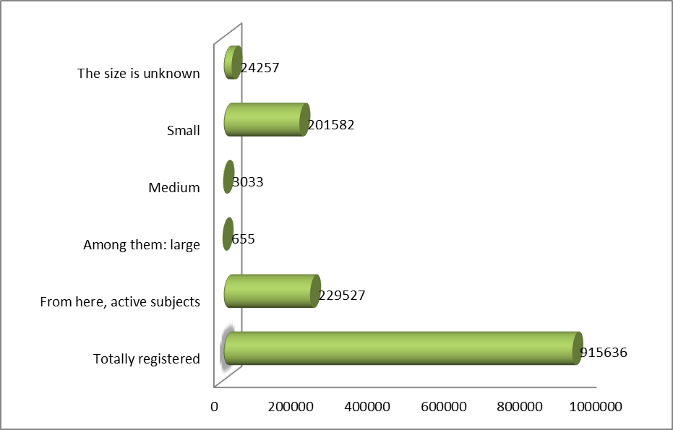
Source: Compiled based on Geostat data
Chart 1. Business entities by enterprise size as of January 1, 2023
Thus, as we have already mentioned, the contribution of small businesses to the Georgian economy is quite significant. This is confirmed by the fact that in 2021, 44.7% of the total turnover of enterprises comes from small and medium-sized businesses, of which 18.5% of total turnover comes from small businesses, 53.1% of released products, 52.5% of added value, 51.8% of employees, 56% of employees come from small and medium-sized enterprises. % and 57.7% of the accrued profit. Therefore, promoting and encouraging the development of small and medium-sized businesses is a very important and necessary component for the development of the country (see diagram 2).
In recent years, the total turnover index has been increasing, the share of large enterprises in the total turnover index is increasing every year, while the share of small and medium-sized enterprises in the total turnover volume is decreasing. Which is a very noteworthy fact. Therefore, it is necessary to pay more attention to encouraging the activities of small and medium enterprises. (see diagram 3).
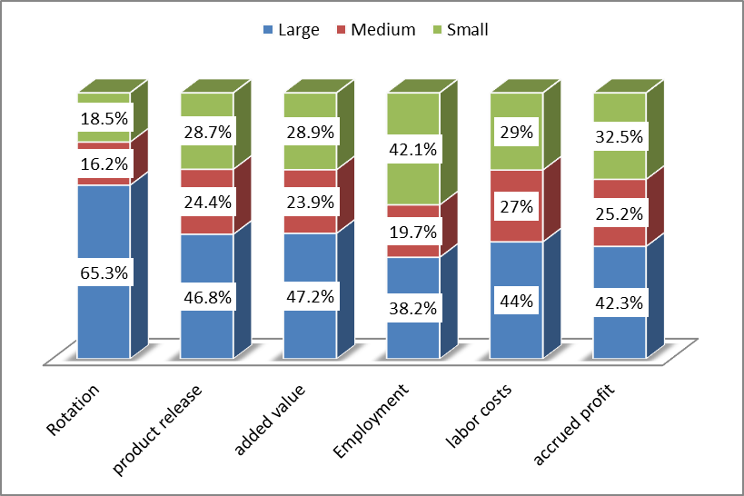
Source: Chart based on Geostat data.
Chart 2. Key indicators by enterprise size in 2021 (in %)
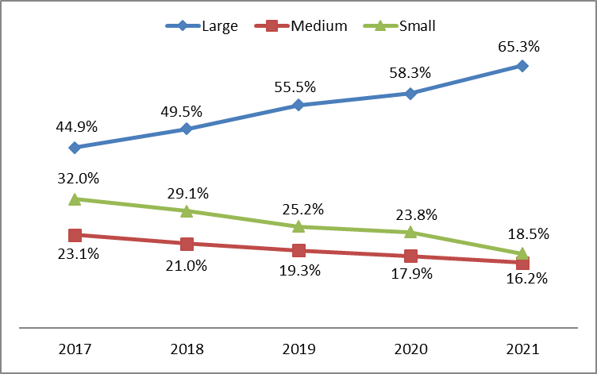
Source: Chart based on Geostat data
Diagram 3. Turnover by enterprise size 2017-2021 (in %)
In addition, it is significant that the current crisis has affected small and medium-sized businesses according to the number of employees, while the number of employees in large businesses is characterized by an increase compared to previous years. In particular, the number of employees in small businesses is characterized by a decreasing trend compared to the previous year, the situation is slightly corrected in 2021. (see diagram 4).
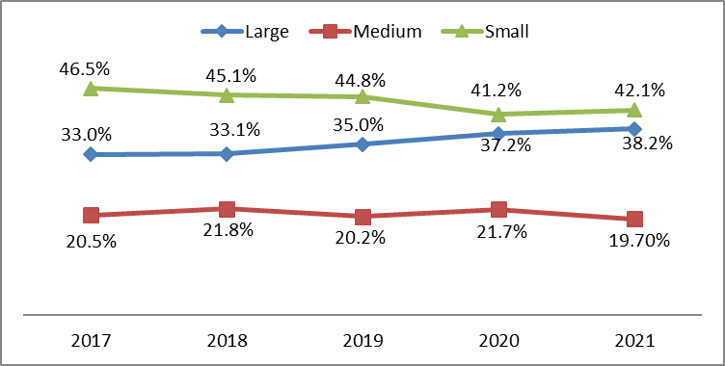
Source: Chart based on Geostat data
Diagram 4. Increase/decrease in the number of employees compared to the previous year in 2017-2021 (in %)
Volumes of investments in fixed assets should be mentioned separately. The indicator started to decrease in 2018, and in 2021 it almost returned to the indicator of 2017. There is no particular trend in the direction of medium and small businesses, although there is a steady increase in the share of large businesses (see diagram 5).

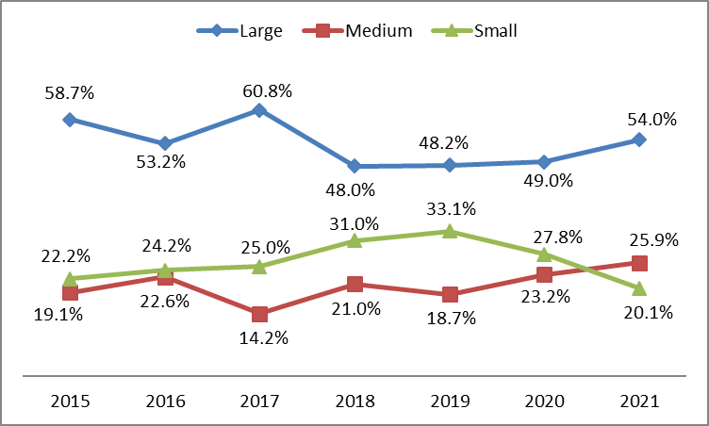

Source: Chart based on Geostat data
Chart 5. Investments in fixed assets 2015-2021 (in %)
Based on the analysis of the given statistical data, we can confidently say that small business is one of the main components of the Georgian economy. Several organizations such as:
- Run the existing program with the Ministry of Economy and Sustainable Development in Georgia;
- Innovation and Technology Agency of Georgia under the Ministry of Economy and Sustainable Development;
- Business associations supporting small and medium entrepreneurship, such as:
- Chamber of Commerce and Industry;
- Association of Small and Medium Enterprises of Georgia;
- Association of employers.

the main problems in small and medium-sized business are crisis conditions
In order to determine the main problems facing small and medium-sized businesses in the current global crisis, we conducted a survey with the participation of 57 small and 24 medium-sized enterprise heads.
What problems did you encounter in the process of organizing the business? According to 35% of the surveyed respondents, the biggest problem for them when starting a business was the lack of initial capital and the difficulty of obtaining loan capital, according to 31%, the problem was a shortage of qualified personnel, lack of access to state programs became a problem for 18% of respondents, and 4% There were no problems in organizing the business (see diagram 6).

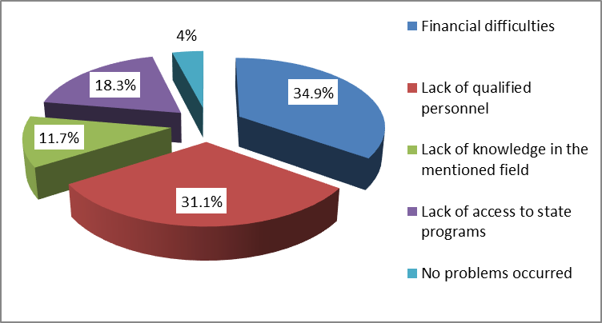
Source: The chart is based on the results of a survey of respondents
Diagram 6. What problems did you encounter in the process of organizing the business?

To the question, what are the main problems you face in the process of doing business? 46% of the respondents stated that an important problem for them in the process of doing business is the rising prices of raw materials in the crisis, the main problem for them is the high-interest rate of bank credit for 42.6%, and according to 11.4%, the main problem is the lack of state support programs (see diagram). 7).
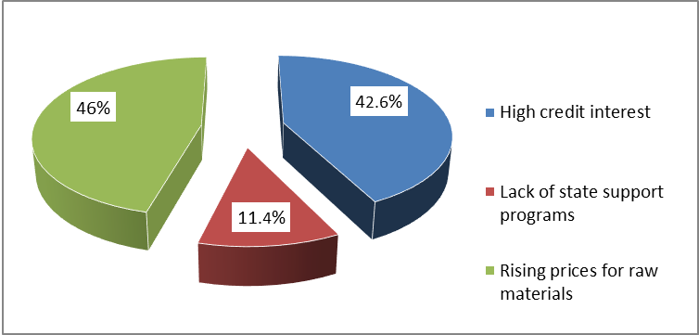
Source: The chart is based on the results of a survey of respondents
Diagram 7. What are the main problems you face in the process of doing business?

The answers to the following question were interesting: do you know about state support programs for small and medium enterprises? The existence of such programs is known to 58.5% of respondents, but they need more information to participate in them, 14.8% use these programs, and 26.7% of respondents have not heard about such programs at all.
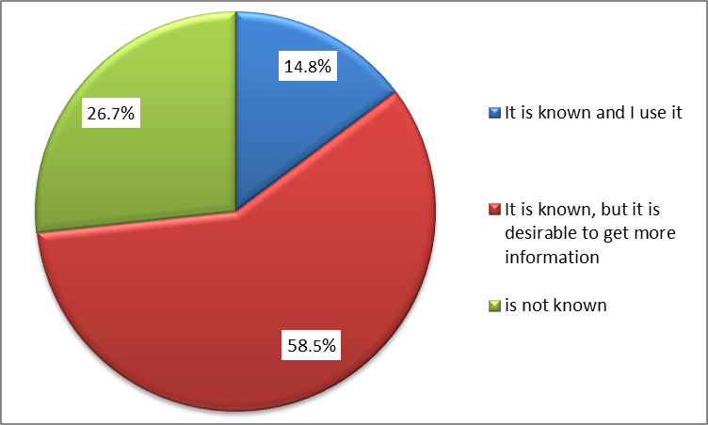
Source: The chart is based on the results of a survey of respondents
Chart 7. Are you aware of state support programs for small and medium enterprises?

When asked what kind of state support do they need the most? According to 38.9% of the surveyed respondents, the most important thing for them is advisory support from the state, 28.5% think that financial support is the most important, including subsidies and tax benefits, 18.4% are in favor of expanding property support from the state, and they put informational support in the first place. 14.2% of respondents (see diagram 8).
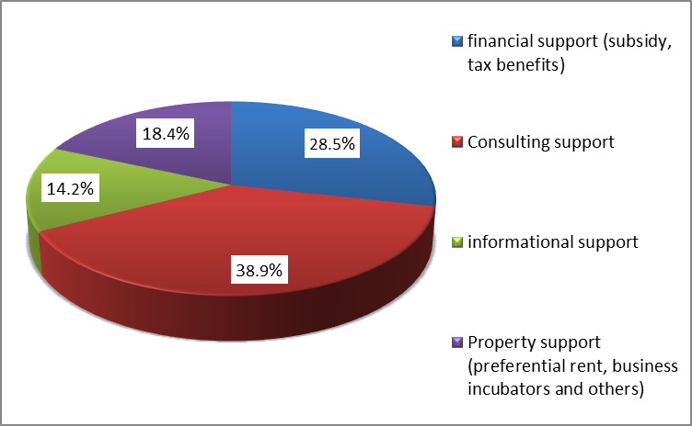
Source: The chart is based on the results of a survey of respondents
Figure 8. What kind of state support do they need the most?

Thus, based on the analysis of the results of the survey of the respondents, it became clear that the main problems in the process of business organization are the lack of initial capital, the difficulty of obtaining loan capital, and the shortage of qualified personnel, while in the process of business production, the rising prices of raw materials and the high percentage of bank credits. Despite the fact that the majority of respondents are aware of the state support programs for small and medium-sized businesses, most of them suffer from a lack of information and only 14.8% take advantage of these programs. Among the types of support provided by the state, a significant majority of them considered consulting support and financial support to be the most important.

main findings and recommendations of research
The sustainable development of small and medium entrepreneurship in the country was significantly damaged first by the restrictions caused by the Covid pandemic, and at the modern stage by the economic crisis in the world, including in Georgia. Despite the fact that many economic and political forecasts are made, it is difficult to determine when a number of economic parameters, as well as the purchasing power of the population, will return to their old level. It is particularly difficult to determine what the crisis will change in the structure of the economy, how much the situation will change in the existing markets, and which new markets will be formed.
For the development of small and medium-sized businesses, the implementation of such measures by the state, which will help them to pass through the crisis period quickly and with fewer losses, and effectively use the new opportunities created by post-crisis changes, is of particular importance.
It is necessary to single out the main factors that determine the implementation of measures for the protection and promotion of small and medium entrepreneurship:
• Under the conditions of the past Covid pandemic and the current economic crisis, small and medium entrepreneurship has been the most affected since the subjects of the mentioned sector do not have either human, technical, or financial resources to quickly adapt to the newly emerging conditions.
• Due to the fact that the small and medium production sector has a great influence on the level of unemployment in the country, therefore it is necessary to carry out such measures that will contribute to the preservation of jobs in the country and the creation of new ones.
• An integral approach and coordination to the comprehensive support and encouragement of small and medium-sized businesses are important. It should be based on a balanced and coherent strategy. However, since the SME support system is complex and includes: banks, government and financial policy implementing agencies, donors, non-governmental organizations, and technical assistance providers, it is necessary to mobilize this system in such a way that all of them mutually agree to support SMEs.
• In general, the governments of the countries in crisis conditions make their main efforts on the short-term survival of enterprises, i.e. improving liquidity, which they try to achieve by postponing taxes and loans, allocating preferential credits and other measures, and do not think about their further development. Therefore, although it is important to save small and medium-sized enterprises during the crisis, it is no less important to develop and implement long-term survival and development programs.
Taking into account the current situation, international experience, and the analysis of the results of interviews and surveys with representatives of small and medium-sized businesses, measures to support and encourage them in the current crisis and post-crisis period should be based on four main principles, namely:
• Facilitating the access of small and medium-sized businesses to support programs so that as many enterprises as possible can participate in them. It is important to shape the procedures in such a way as to ensure a simple and understandable cycle for this sector. If we look at the experience of successful countries in this regard, they offer small and medium businesses the principle of "one window". For example, the Australian government has created a separate website for small and medium business entities, where there is information about all the support programs implemented by the government, as well as a hotline, where all the necessary procedures are explained to interested parties. But being informed about what opportunities exist is not enough. Of particular note is the fact that fast and easy access to most small and medium-sized business services. Small and medium business support programs operating in Georgia offer them fairly simple and easily accessible forms and procedures. Despite this, a part of the entrepreneurs does not know about these programs at all, and a large part knows but cannot use them (see diagram 7). The reason for all this lies in the fact that access to the Internet is not available everywhere (especially in the regions), as well as the low level of technical skills, the heads of the enterprise have the insufficient financial knowledge and generally low level of working with documentation. Therefore, even the simplest procedures for small entrepreneurs may turn out to be quite difficult if there are no consulting centers and proper information support, which is requested by a large number of managers of small and medium-sized enterprises (see diagram 8). It should also be noted that information about all opportunities is available on the websites of the relevant organizations.
• Addressing the needs of SMEs in a coordinated ecosystem. For the effectiveness of the response measures carried out by the Government of Georgia to the current crisis, it is necessary to coordinate the work of all interested entities, since it is necessary that the activities of all private, public and also international entities are directed to the full fulfillment of the main goals, i.e. it is necessary to fully activate the ecosystem. In this regard, the first and necessary step is to align the current and planned programs with the interests of the interested subjects, as well as to identify their needs. And with such coordinated activities and efforts, the support programs will be evaluated and the feedback will be deepened with the small and medium business sector based on the analysis of the obtained results. In the conditions of the current crisis, in most countries it is difficult to follow the uniform progress of the implementation of support programs, and it is not possible to make timely corrections in the current programs. That is why the full mobilization and full involvement of the interested subjects is an important issue.
• Sustainable development of the small and medium business sector and increasing competitiveness. In the post-crisis period, the rate of recovery of the country's economy will depend on how quickly and completely small and medium-sized businesses will be able to return to sustainable operation with the help of support and stimulation measures. In this regard, it is necessary to improve three directions, namely: increasing access to the local market, facilitating entry into the foreign market, and increasing productivity, all of which will enable the small and medium business crisis to be overcome and sustainable development. It is necessary for the government to increase the share of small and medium enterprises in state procurement, and this will significantly increase their competitiveness. For example, South Korea's Ministry of SMEs and Startups has developed and implemented measures to ease administrative barriers to participation in public procurement. In countries with developed and established markets, governments offer small and medium-sized businesses advance payments for goods and services delivered. In this regard, the Georgian government still has a lot to do.
• Planning for the "new reality" caused by the Covid pandemic and the current economic crisis. In this regard, developers of state policies and support programs, in agreement with the representatives of the small and medium business sector, should initially evaluate the current strategies, make adjustments if necessary and adapt to the established environment that was created under the crisis. It is also necessary to make appropriate conclusions for the post-crisis period and develop a plan for coming out of the crisis. It is important to strengthen support for enterprises that produce high-potential scientific and innovative products, whose implementation of technical assistance programs that will promote product innovation, the adoption of new technologies, digitalization, and the creation of modern business models will play an important role in the cooperation of small and medium-sized businesses operating in various fields. in development.

conclusion
Thus, the tasks of small and medium business development should be solved in the context of increasing the scale of external and internal challenges facing Georgia, which requires further intensification of efforts to solve the accumulated problems. In order to realize the entrepreneurial potential of the country, taking into account the socio-economic and foreign economic conditions, the importance of the strategic coordination mechanism for the development of small and medium-sized businesses is intensified.
Every crisis brings both problems and opportunities. Examples of such opportunities for small and medium-sized businesses can be considered: the possibility of entering new sales markets, expanding the share of non-commodity exports of small and medium-sized businesses, which will significantly increase their competitiveness in regional and international markets; Incorporating emerging industries into value chains.
It is clear that small and medium-sized businesses are the basis and driving force for the development of the post-crisis economy. Therefore, it is of great importance that small and medium-sized businesses fully absorb the support and incentive programs planned in Georgia and use the significant opportunities that these programs create, as a result of which the country's economic growth and development will be accelerated, the living standards of the population will rise, and the country's competitiveness will increase.

References
1. Abiodun Eniola, H. Entebang, Government Policy and Performance of Small and Medium Business Management, International Journal of Academic Research in Business and Social Sciences, volume 5, No 2 (2015), 237-248
http://dx.doi.org/10.6007/IJARBSS/v5-i2/1481
2. Meath, M. Linnenluecke, Griffiths, Barriers and motivators to the adoption of energy savings measures for small- and medium-sized enterprises (SMEs): the case of the Climate Smart business cluster program, J. Clean. Prod., 112 (A., 2016), 3597-3604.
https://doi.org/10.1016/j.jclepro.2015.08.085
3. Pongelli, A. Majocchi, J. Bauweraerts, S. Sciascia, M. Caroli, M, A. Verbeke, The impact of board of directors’ characteristics on the internationalization of family SMEs. J. World Bus (2023)58, 101412.
https://doi.org/10.1016/j.jwb.2022.101412
4. F. Testa, N.M. Gusmerottia, F. Corsini, E. Passetti, F. Iraldo, Factors affecting environmental management by small and micro firms: the importance of entrepreneurs’ attitudes and environmental investment, Corp. Soc. Responsib. Environ. Manag., 23 (6) (2016), 373-385,
https://doi.org/10.1002/csr.1382
5. G. Sam Ahinful, J. Danquah Boakye, N. Dwomoh Osei Bempah, Determinants of SMEs’ financial performance: evidence from an emerging economy, Journal of Small Business and Entrepreneurship, (2019), 362-389
https://doi.org/10.1080/08276331.2021.1885247
6. H. Gebauer, M. Paiola, B. Edvardsson, A capability perspective on service business development in small and medium-sized suppliers, Scandinavian Journal of Management, volume 28, issue 4, (2012) 321-339.
https://doi.org/10.1016/j.scaman.2012.07.001
7. H. Zhang, A. Veltri, J. Calvo-Amodio, K. R. Haapala, Making the business case for sustainable manufacturing in small and medium-sized manufacturing enterprises: A systems decision making approach, journal of cleaner production, volume 287 (2021), 125038
https://doi.org/10.1016/j.jclepro.2020.125038
8. J. Jansson, J. Nilsson, F. Modig, G. Hed Vall, Commitment to sustainability in small and medium-sized enterprises: the influence of strategic orientations and management values, Bus. Strat. Environ., 26 (1) (2017), 69-83.
https://doi.org/10.1002/bse.1901
9. M.C. Stoian, P. Dimitratos, E. Plakoyiannaki, SME internationalization beyond exporting: A knowledge-based perspective across managers and advisers, Journal of World Business, Volume 53, Issue 5, (2018), 768-779
https://doi.org/10.1016/j.jwb.2018.06.001
10. P. Lückmann, C. Feldmann, Success Factors for Business Process Improvement Projects in Small and Medium Sized Enterprises – Empirical Evidence, Procedia Computer Science, Volume 121, (2017), 439-445.
https://doi.org/10.1016/j.procs.2017.11.059
11. P. Salimzadeh, J. Courvisanos, A conceptual framework for assessing sustainable development in regional SMEs, J. Environ. Assess. Pol. Manag., 17 (4) (2015), 1-17,
https://doi.org/10.1142/S1464333215500398
12. P. Westhead, M. Wright b, D. Ucbasaran, The internationalization of new and small firms: A resource-based view, Journal of Business Venturing, Volume 16, Issue 4, (2001), 333-358.
https://doi.org/10.1016/S0883-9026(99)00063-4
13. R. Costa-Climent, D. M. Haftor, M. W. Staniewski, Using machine learning to create and capture value in the business models of small and medium-sized enterprises, international Journal of Information Management, (2023), 102637.
https://doi.org/10.1016/j.ijinfomgt.2023.102637
14. S. Tornabene, I. Nilsson, Rail transit investments and economic development: Challenges for small businesses, journal of transport geography, volume 94, (2021), 103087.
https://doi.org/10.1016/j.jtrangeo.2021.103087
15. T. Marie Sohns, B. Aysolmaz, L. Figge, A. Joshi, Green business process management for business sustainability: A case study of manufacturing small and medium-sized enterprises (SMEs) from Germany, Journal of Cleaner Production, Volume 401, (2023), 136667.
https://doi.org/10.1016/j.jclepro.2023.136667
16. W. Park, Ch. Soo Sung, Ch. Gyu Byun, Impact of Unlisted Small and Medium-Sized Enterprises’ Business Strategies on Future Performance and Growth Sustainability, journal open innovation, volume 5, issue 3, (2019), 60
https://doi.org/10.3390/joitmc5030060
17. Y. Zhang, E.Y Ayele, Factors Affecting Small and Micro Enterprise Performance with the Mediating Effect of Government Support: Evidence from the Amhara Region Ethiopia. Sustainability (2022) 14, 6846
https://doi.org/10.3390/su14116846

Ministry of Economy and Sustainable Development of Georgia. Small and medium business development strategy of Georgia 2021-2025. https://www.economy.ge/uploads/files/2017/ek__politika/sme_strategy/sme_development_strategy_2021_2025_.pdf
National Statistical Service of Georgia. Business entities according to organizational-legal form. 2023 by January 1https://www.geostat.ge/ka/modules/categories/67/organizatsiul-samartlebrivi-formebis-mikhedvit
National Statistical Service of Georgia. Business sector in Georgia: 2021, 2020, 2019, 2018, 2017. Statistical publication. Tbilisi. https://www.geostat.ge/ka/single-categories/105/biznes-seqtori-sakartveloshi

