ANALYSIS OF THE CORRELATION BETWEEN INVESTMENTS, THE REAL COST WITH LABOR AND TOTAL EMPLOYABILITY IN THE EU, IN THE ECONOMIC CONTEXT MARKED BY THE COVID-19 PADEMIC
Cătălin Ionuț SILVESTRU
Bucharest University of Economic Studies, 071131, Romania
catalin@ase.ro
Ana-Maria IFRIM
University Politehnica of Bucharest, Romania, 060042, Romania
amifrim@gmail.com
Ramona Camelia SILVESTRU
Technical University of Civil Engineering Bucharest , 020396, Romania
ramona.silvestru@gmail.com
Ionica ONCIOIU
Titu Maiorescu University Bucharest, Romania, 040441, Romania
office.university.edu@gmail.com
Gabriela Elena BIŢAN
Bucharest University of Economic Studies, 071131, Romania
gabriela_bitan@yahoo.com
Stelian-Mircea OLARU
The Bucharest University of Economic Studies, 071131, Romania
olaru_stelian@yahoo.com

Abstract
The objective of the study conducted by the authors is the analysis of the impact of two indicators - the total value of investments and the real cost of labor - on the indicator total employability, in the current economic context, marked by the COVID-19 pandemic. To achieve this goal, the linear regression model was used in the analysis of the correlation between total employment, real unit labor costs and total investment volume. As a result of determining the correlation coefficients, it turned out that the number of employees depends largely on the total value of investments, which has a major impact on the labor market. On the other hand, it turned out that, in the current economic context, the need for jobs is much higher and employability no longer depends on real unit labor costs. These results are consistent with existing theoretical studies. We consider that the estimates made on the impact of the total value of investments and the real cost of labor on employability are useful in testing and implementing theories of investment and consumption in conditions of uncertainty.

Key words: correlation; employability; investment; labor cost; linear regression.

JEL Classification: I15

Introduction
What started in China and was initially seen as a local problem has turned into something much more serious that can push the global economy into the biggest recession since 1930. As COVID-19 spread globally and profoundly affected the lives of the population, there were major changes in the perception of both economic and private activities. At the labor market level, digital technology has helped both employees and companies to continue their activity in the context in which the existence of the virus has become a challenge on public health, quality of life, but also on national economies. The first concern of governments around the world is to protect the health and safety of their citizens, but also to take economic measures to reduce the impact of the pandemic. Thus, in an attempt to combat the virus, European Union member states have had to take drastic measures that have put their economies in a hibernation state, which has led to a decrease in economic activity by about a third and, implicitly, this decrease also led to a reduction in the number of employees (Eurostat, 2020).
In the first quarter of 2020, the European Union's economy decreased by almost 16% compared to the last quarter of 2019 (Eurostat, 2020). This result has led to unprecedented measures to help Member States' economies. The main obstacles to the economic development of the Member States were the reduction of demand, the reduction of supply, the labor force was and is unavailable due to disease, quarantine or the fact that they have to take care of relatives and children whose schools are closed. Through proposed policies aimed to support incomes, jobs and investments, economic activity should return with the relaxation of the imposed measures.
The COVID-19 crisis risks leading to a further expansion of economic divergences within the European Union. While the pandemic is a symmetrical shock, the impact differs between Member States depending on the severity of the pandemic, the strictness of the related containment measures and the fiscal policy adopted. With the minimization of isolation measures, a common approach is needed at the level of the European Union, an approach that generates investments and the creation of new jobs. Otherwise, the major risk is to create large differences between the states of the European Union, which in the long run is not desirable. According to the forecast report issued by the European Commission in the spring of 2020, the aggregate general deficit is expected to increase from 0.6% of GDP in 2019 to 8.5% of GDP both in the euro area and globally (European Economic Forecast, 2020). Also according to the mentioned document, the year 2021 will have a deficit of up to 3.5% of GDP in both areas due to the expected return in economic activity and the development of most of the temporary measures adopted in response to the COVID-19 crisis.
From the point of view of the labor market, many workers have lost their jobs and young people who want to get a job no longer have the same chances as before the declaration of the pandemic. Thus, according to European Commission documents, the unemployment rate in the euro area is expected to increase from 7.5% in 2019 to about 9.5% this year and decrease in 2021, still remaining well above the level or pre-pandemic (Eurostat, 2020, European Economic Forecast, 2020).
Depending on the measures taken, the unemployment rate is expected to increase differently in different countries. In this context, bold political and economic measures are needed to limit job losses. Thus, the European Union has adopted a new instrument, The European Instrument for Temporary Support to mitigate Unemployment Risks in an Emergency (SURE), which seeks to support companies to alleviate the unemployment rate. This instrument will provide financial assistance in the form of favorable loans from the European Union to Member States totaling EUR 100 billion (Eurostat, 2020). These loans will help Member States cope with the sharp rise in public spending in the context of the need to maintain employment.
The objective of this study is to analyze the impact that two indicators have: the total value of investments and the real cost of labor on the total employability indicator. The importance of this study also aims at the fact that the study of the effects of the pandemic on the labor market must be carried out in correlation with the impact of the economic crisis that will be felt strongly and for a longer period of time. The results show that there is a bilateral causal relationship between total employment, real labor costs and the volume of total investment in the current context of the labor market. This study is important in the current context of the economic crisis, generated by the COVID-19 pandemic, as it shows the most obvious effects of investment on labor market dynamics, effects that can already be seen in the growing processes and phenomena of discouraging unemployment, in especially among the younger generation.
The paper is structured as follows: section 2 includes a brief presentation of the literature in the current economic context, section 3 presents the research methodology, section 4 describes the data used and analyzes the results obtained and section 5 is allocated to the conclusions.

Literature review
The economic impact of the COVID-19 pandemic has been assessed as a major one, which involves provocative political and economic decisions (Albu et al., 2020; Coibion et al., 2020). Thus, three indicators are identified that can influence the market- stock market volatility, economic uncertainty and subjective uncertainty in business expectations surveys - which provide real-time uncertainty measures (Baker et al., 2020). The virus can be just as contagious from an economic point of view as it is from a medical point of view. This has led the International Monetary Fund (IMF) to say it sees "worse" situations for the global economy (https://www.imf.org/external/index.htm). The COVID-19 pandemic has shown that society needs to prioritize social goals, including public health and welfare (Barneveld et al., 2020).
The COVID-19 pandemic has led to over 87,270,673 confirmed cases and over 1,883,912 deaths globally (https://www.worldometers.info/coronavirus/?). It has also raised fears of an impending economic crisis and recession (Jordà et al., 2019). Social distancing, isolation and travel restrictions have led to a reduction in the workforce in all economic sectors and have led to the loss of many jobs. Schools closed and the need for manufactured goods and products decreased. Instead, the need for medical supplies has increased significantly. The food sector is also facing increased demand due to the panic that has set in among the population and which has led to the need for food storage. In almost all scenarios considered internationally, at the height of the disease, between 10% and 20% of the population (33 to 66 million people) suffer from an active infection at the same time (Eurostat, 2020). This level of infection in the population is likely to require a significant reversal of the workforce, from work to self-sufficiency and recovery or care of the sick, for a period of a few weeks or more. Fearing that a new recession might follow, times like these require resilient and strong leadership in health, business, government and society at large (Nicola et al., 2020).
In this context it must be considered that the development of new communication technologies has led to changes in the labor market in terms of its traditional structure due to the penetration of the telework phenomenon (Eurofound, 2020). This phenomenon has led to a profound transformation in the dynamics of the labor market in the EU (Gschwind and Vargas, 2019). According to some studies, it is possible in the future to talk about ways derived from the form of telework without losing the essential characteristics of the employment contract (Vilhelmson and Thulin, 2016; Dingel and Neiman, 2020). Thus, it will be possible to clarify the matrix of employability on the labor market. In this context, it is imperative that decision-makers understand how medical, economic and financial infrastructure should function in such a period. Immediate rescue measures need to be implemented and adjusted and medium and long-term planning is needed to rebalance and re-energize the economy in the wake of this crisis. A large socio-economic development plan to encourage entrepreneurship is also needed.

Research methodology
Sustainable development is described as the need to maintain a permanent income for humanity, generated by capital stocks. Thus, at least from this perception, constant stocks of human, natural and social capital (Serageldin, 1996) are considered necessary and often sufficient criteria for sustainable development (Pearce and Atkinson, 1993; Pearce and Barbier, 2000).
In the context of those mentioned above, we can say that the labor market is in a close relationship with other internal and external factors. Thus, the notion of dependence has a broader meaning. As regression establishes the link between an imposed deterministic variable and a random variable, we can use it as an analysis tool. Thus, in the present research we used the linear regression model in the analysis of the correlation between total employment, real unit labor costs and total investment volume. Estimating the links between different variables, taking into account the random aspect, is particularly important for the analysis of characteristics, so that the use of the regression line that involves an estimate, serves to predict the values between total employment, real unit labor costs and total investment volume. The regression method is generalized by the theory of the "general linear model", which allows several dependent variables simultaneously and also factorial variables that are not linearly independent.
The econometric analysis of the model involves identifying the regression that includes both the dependent and the independent variable. For the analysis performed in the research, the dependent variable is total employment and the independent variable is total investment volume. Also, the correlation matrix will be run to observe the relationship between the variables. The problem of estimating prediction errors will be treated with the presentation of the general model which involves: defining the equation related to the model $\overline{y}=a+\text{bx}$. Applying the least squares method, the coefficients “a” and “b” will be obtained. The next step is to establish a confidence interval regarding the evolution of employability in the context of the analyzed data. The t-student distribution was used to establish the confidence interval, due to the small volume of data analyzed. Thus, the confidence interval is: $(y_{0}−t_{1−α/2;n−2}s(y_{0}),y_{0}+t_{1−α/2;n−2}s(y_{0}))$. When the values are further away from the average value, the confidence interval increases and the forecast is accompanied by larger errors. The predictions related to the analyzed values are more accurate close to the average. Regression analysis is a method used to allow predictions. However, it is interesting to know if the two identified variables are associated and what is the degree of association. Such a measure is provided by the correlation coefficient, denoted r. It has values from –1 to +1, a zero value indicates no association, +1 shows a perfect positive association (correlation), a value of -1 shows a perfect negative association. The correlation coefficient is final with the help of the relation:

$$r=\frac{\sum{(x_{i}−\overline{x})(y_{i}−\overline{y})}}{\sqrt{(\sum{(x_{i}−\overline{x})^{2})(\sum{y_{i}−\overline{y})^{2})}}}}$$

The random variables x and y are in this situation the analyzed indicators: total employment, real unit labor and total investment volume.

Data analysis
In the second quarter of 2020, still marked by COVID-19 isolation measures in most EU Member States, GDP fell by 12.1% in the euro area and by 11.9% in the European Union compared to the quarter previously, according to a preliminary estimate published by Eurostat. This decline was accentuated compared to the first quarter of 2020 when GDP had fallen by 3.6% in the euro area and by 3.2% in the European Union (Eurostat, 2020). In the period 2001-2019 there is a constant evolution of the number of employed persons. The year 2019 showed that investments in the Member States of the European Union had a consistent increase, which also generated an increase in the number of employees and the cost of labor (Eurostat, 2020).
It is expected that the COVID pandemic will change this evolution without an active investment plan developed both at the level of the European Commission and at the level of each member state. The economic crisis that can be triggered due to the COVID pandemic can negatively influence the value of the employability indicator in the context in which the investment indicator will not have the expected increase. In order to analyze the impact of labor costs, the value of investments on employability in the European Union, the data were analyzed by going through the steps presented in the paragraph research methodology. Thus, in the first stage the indicators total employment and total investment were analyzed, later the influence of real unit costs on total employment was analyzed.
The analyzed period includes the years 2001 and 2019, semesters 1 and 2, the year 2020, the data being presented in table no. 1. The values and information in this study are taken from Eurostat publications.

Table 1. Evolution of indicators related to the labor market and investments
An | Total employment (percentage change on preceding year) | Real unit labour costs (percentage change on preceding year) | Total investment, volume  (percentage change on preceding year)
2001 | 0,3 | -0,8 | 1,2
2006 | 0,3 | 0,2 | -0,6
2011 | 0,1 | -0,4 | 0,4
2016 | 1,3 | -0,1 | 3,3
2017 | 1,6 | -0,2 | 3,7
2018 | 1,4 | 0,5 | 2,9
2019 | 0,9 | 0,1 | 5,7
2020  (Spring 2020) | -4,4 | 3 | -13,2
2020 (Autumn 2020) | -4.5 | 2,3 | -10.3
Source: Eurostat, 2020

An overview on the evolution of the total number of employees, in relation to the total investments, is presented in figure no. 1.

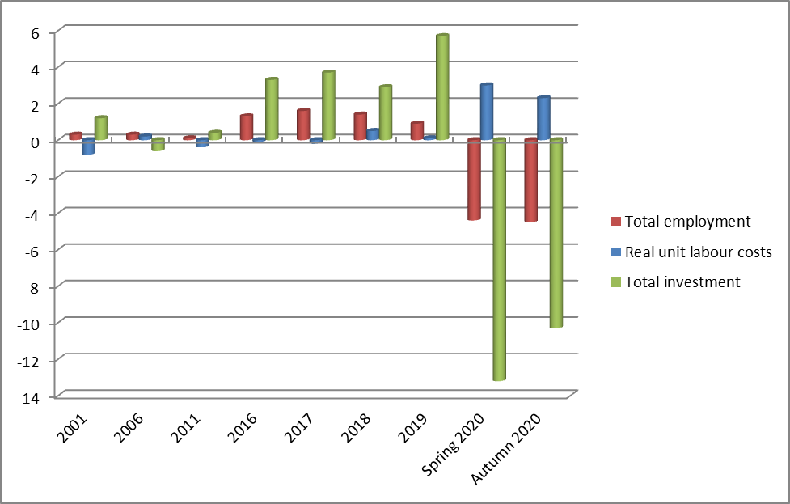
Figure 1 – Evolution of total number of employees in ralation to the total investment
Source: Own contribution
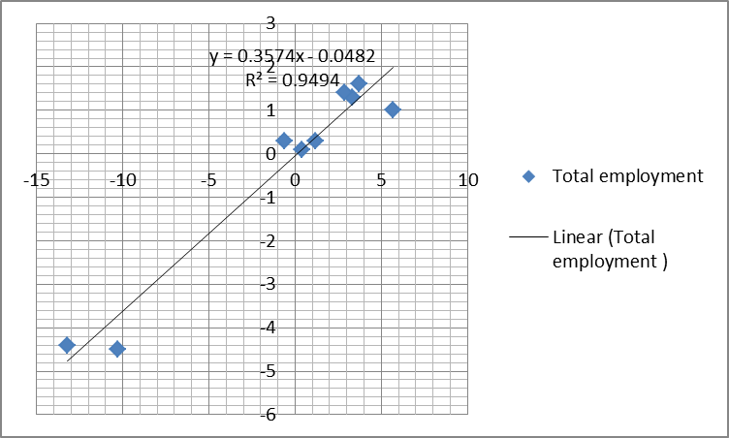
Figure 2 – Estimated values of the regression line
Source: Own contribution

As previously stated, Table 1 presents information related to the analyzed period: from 2001 to 2019, the second and third quarters of 2020 regarding total employment, real unit labor costs and total investment, volume. In order to analyze the dependence between the total number of employees and the value of investments, the situation was taken into account in which the dependent variable is total employment and the independent variable total investment.
The dependence between the two variables under analysis results from the calculation of the determination coefficient R2, which is equal to the square of the multiple correlation coefficient. The value of the coefficient of determination is 94.94% which means that there is an accepted direct link between the two variables. The graph presented in figure no. 2 shows the regression line. Excel was used to obtain this graph. The information regarding the regression data are presented in table no. 2 and were calculated using Excel.

Table 2. Statistical information obtained as a result of the application of the linear regression method
Indicator | Value
Multiple R | 0.9744
R Square | 0.9494
Adjusted R Square | 0.9421
Standard Error | 0.5773
Mean | -0.322
Variance | 5.7594
Pearson Correlation | 0.9744
Valoarea t95% | 2,306
Limita inferioara | -1,6875
Limita superioara | 1,0431
Source: Eurostat, 2020

According to the statistical data from table no. 2, the evolution of the number of employees is highly dependent on the value of investments. The confidence interval related to the evolution of the number of employees is (-1.6875; 1.0431).
As the values xi are not far from the average of x, the confidence interval is not very long, which means that the forecast from the point of view of the evolution of employability is not accompanied by large errors.
From the point of view of the analysis of the correlation coefficient we can say that the association between the two analyzed variables is a perfect one. As can be seen in table no. 3, the value of the correlation coefficient is 0.9744, a value that is close to 1, which means that the number of employees depends largely on the volume of investments.

Table 3. The correlation coefficient related to the two analyzed indicators: total investment and total employment
 | Total investment | Total employment
Total investment | 1
Total employment | 0.9744 | 1
Source: Own contribution
Table 4. The correlation coefficient related to the two analyzed indicators: total investment and real unit labor costs
 | Total employment | Real unit labour costs
Real unit labour costs | 1
Total employment | -0.8933 | 1
Source: Own contribution

From the previous analysis it is observed that the value of investments in the economy is an important lever for increasing the employability rate. If before the declaration of the COVID 19 pandemic, the labor cost had very small variations, in 2020 an increase of this cost can be observed, which can depend a lot on the economic blockage created due to the COVID 19 pandemic. Following the analysis of the correlation between total employment and real unit labor costs, it is observed that the correlation coefficient is -0.8933, there being a weak correlation between the analyzed variables (table no. 4). Thus, in the current economic context, it is an expected result. The need for jobs is much higher and employability no longer depends on real unit labor costs.
At the same time, given the severity of COVID-19, the correlation between total employment, real unit labor costs and the total volume of investments contributes to the formation of a new thinking, a new conception of both managers and all employees.

Conclusions
The analysis of these results can be useful for decision makers, to visualize the magnitude of the impact that the COVID-19 pandemic has from an economic point of view, in order to establish guidelines for action. Also, all the estimates made regarding the evolution of employability are considered potentially useful in testing and implementing theories about investment and consumption in conditions of uncertainty.
The analysis shows that this pandemic represents a very big shock for the global and European economy, with very serious economic and social consequences. Economic activity in Europe suffered a severe decline in the first half of 2020, then began to recover, as isolation measures were gradually lifted. However, the recurrence of the pandemic in the last two months of 2020 results in disruptions, as national authorities introduce new public health measures to limit the spread of the virus. The epidemiological situation means that growth projections over the forecast horizon are subject to a high degree of uncertainty and risks. Job losses and rising unemployment have put severe pressure on European Union countries. The political measures taken by the Member States, together with the initiatives at EU level, have helped to cushion the impact of the pandemic on labor markets. However, unemployment will continue to rise in 2021 as Member States gradually phase out emergency support measures, but should improve in 2022 as the economy continues to recover.
The COVID-19 pandemic has affected global organizations, financial markets and the global economy. The economic shock was most visibly represented by the massive job losses on the one hand, and, on the other hand, by the force and high volatility with which the stock market reacted. In principle, the results of the research presented in this paper are consistent with existing theoretical studies. It was found that there is a direct relationship between the evolution of total investments (both public and private) and the evolution of the total number of employees. This means that any increase in the volume of investments also leads to an increase in the number of employees. Using the linear regression model, a positive correlation was identified between the total number of employees and the total value of investments that has a major impact on the labor market.
The paper suggests that institutional efforts should focus on the development of the investment sector. In order to overcome the crisis caused by the COVID-19 pandemic and to ensure the sustainability of jobs, it is necessary that both public and private investments can be made urgently. The infusion of capital in the private sector and investments - taking into account the initiative in the private sector and investments in useful social purposes - are essential for reducing poverty and implicitly increasing the employment rate. In parallel with public sector efforts, private investment has tremendous potential to contribute to economic growth. Private markets are the engine of productivity growth, creating productive jobs and higher incomes. If the government plays a complementary role of regulation, financing and provision of services, the private initiative can contribute to the provision of basic services and implicitly to the increase of the employability degree, ensuring at the same time the sustainability of the jobs.
As a result of the COVID-19 pandemic, most job losses occurred in the hospitality industry. Measures taken in Romania regarding technical unemployment, the possibility of working from home for many employees have managed to reduce the effects of reducing the number of employees. As a result of the analysis, the idea of increasing investments at the level of Member States, both public and private investments, in order to increase the degree of employability is supported.

References
- Albu, L.L., Preda, C.I., Lupu, R., Dobrotă, C.E., Călin, G.M., Boghicevici, C.M. (2020). Estimates of Dynamics of the Covid-19 Pandemic and of its Impact on the Economy. Rom. J. Econ. Forecast. 2020, 13, 5–17.
- Baker,S., Bloom, N., Davis, S., Terry, S. (2020). COVID-Induced Economic Uncertainty, NBER Working Paper No. 26983 Issued in April 2020 NBER Program(s):Economic Fluctuations and Growth
- Barneveld, K., Quinlan, M., Kriesler, P. and Junor, A. (2020). The COVID-19 pandemic: Lessons on building more equal and sustainable societies, The Economic and Labour Relations Review 2020, Vol. 31(2) 133–157
- Chung, H., Gender, (2018), Flexibility Stigma and the Perceived Negative Consequences of Flexible Working in the UK. In Social Indicators Research; Springer Nature B.V.: Dordrecht, The Netherlands, pp. 1–25
- Coibion, O., Gorodnichenko, Y. (2020). Weber, M. Labor Markets during the COVID-19 Crisis: A Preliminary View. SSRN Electron. J. 2020, 41.
- Dingel, J.I., Neiman, B. (2020). How many jobs can be done at home? J. Public Econ. 2020, 189
- Eurofound (2020). Telework and ICT-Based Mobile Work: Flexible Working in the Digital Age; Publications Office of the European Union: Luxembourg, 2020; ISBN 9789289720427.
- European Economic Forecast (2020). Luxembourg: Publications Office of the European Union, Spring 2020
- Eurostat (2020). Available at https://ec.europa.eu/eurostat, accesat la data de 11.12.2020
- Gschwind, L., Vargas, O. (2019). Telework and its effects in Europe. In Telework in the 21st Century; Messenger, J.C., Ed.; Edward Elgar Publishing: Camberley, UK, 2019; pp. 36–75, ISBN 9781789903751.
- Jordà, Ò., Singh, S.R., Taylor, A.M. (2019). Longer-Run Economic Consequences of Pandemics. J. Chem. Inf. Model 2019, 53, 1689–1699.
- Nicola, M., Alsafi, Z., Sohrabi, C., Kerwan, A., Al-Jabir, A., Iosifidis, C., Agha, Riaz Agha, M. (2020). The socio-economic implications of the coronavirus pandemic (COVID-19): A review, International Journal of Surgery Volume 78, June 2020, Pages 185-193Pearce, D., Atkinson, G. (1993). Capital theory and the measurement of sustainable development: an indicator of “weak” sustainability, Ecological Economics, Volume 8, Issue 2, October 1993, Pages 103-108
- Pearce, D., Barbier, E. (2000). Blueprint for a sustainable economy, Edition:1st Edition, First Published: 2000 eBook Published: 2 January 2000
- Serageldin, I. (1996). Sustainability as Opportunity and the Problem of Social Capital, The Brown Journal of World Affairs Vol. 3, No. 2 (Summer / Fall 1996), pp. 187-203 (17 pages), Published By: Brown Journal of World Affairs
- Vilhelmson, B., Thulin, E. (2016). Who and where are the flexible workers? Exploring the current diffusion of telework in Sweden. New Technol. Work Employ. 2016, 31, 77–96
- https://www.imf.org/external/index.htm accesed at 11.12.2020
- https://www.worldometers.info/coronavirus/? Accesed at 06.01.2021

