INVESTMENT CLIMATE OF KAZAKHSTAN: CURRENT STATUS AND PROSPECTS
MADINA TEMIRBULATOVA
L.N. Gumilev National Eurasian University, Kazakhstan
Abugalievna_786@mail.ru

Abstract
Agriculture still remains a little attractive to most of investors. Modern investment into agrarian sector of Kazakhstan and growth of its investment appeal restrains an acute shortage of financial resources, poorly developed material base, low solvent demand of the population therefore growth of investments is one of major factors of ensuring economic development of agriculture in general, improvement of quality of life of the population of the village, updating of regional technical and technological base, fixed assets in agriculture.
In this regard special relevance researches on improvement of mechanisms of attraction of investments into agrarian sector of economy and methods of increase of investment appeal of agriculture for the purpose of ensuring its sustainable economic development. If to consider already created interstate unions, in this plan it is expedient to consider relationship between Romania and Kazakhstan. Kazakhstan and Romania will develop in common electronic decisions in education, medicine and agriculture.
In Kazakhstan communications with inclusion of the earth in market the turn appears need for new financial instruments as mortgage valuable issue papers (bonds). The proposed Мodel of land - mortgage lending will be the main way to increase the investment attractiveness Republic of Kazakhstan.

Key words: Investment, Subsidizing, Land, Mortgage, Lending.

JEL Classification: M 16

Introduction
Investment climate - very capacious concept which is included in calculation by the investor when estimates, are how favorable (or are adverse) in this or that country of a condition for capital investments: condition of policy, economy, right, ideology, culture etc. The investment climate is worse, the above the investor estimates the enterprise risk, the probability of investments is less (Amenova and Akylbayev, 2013, p.6).
Kazakhstan is the leader among the CIS countries in volumes of the saved-up direct investments per capita. On ease of business in 2012 Kazakhstan from 183 countries took the 47th place, having overtaken thus Russia, Belarus and China. However, growth of economy and the growing needs for the capital and technologies, demand carrying out further institutional reforms on creation of attractive investment conditions and bigger protection of the rights of foreign investors in Kazakhstan (Hon, 2012,p11).
The analysis of volumes of the attracted PII over the countries investors during 1993-2013 showed that the main volume of PII arrived from the developed countries, such as: Netherlands (24,1%), USA (15,3%), Great Britain (7,7%), France (6,1%), Italy (3,9%), Canada (3,3%) and Switzerland (3%). Besides, rather large investors in economy of Kazakhstan are Russia (3,9%), China (3,9%) and South Korea (2,8%), the contribution of the investment capital which arrived from offshore zones is also essential (The Virgin Islands – 5%). Shares of other countries are insignificant and make about 11%. In total invests about 116 states in economy of Kazakhstan.
Development of Agro-industrial complex is one of priority tasks for ensuring food security of the country. For further development of agrarian and industrial complex of action of the government will be focused on the solution of two key tasks which most are particularly acute today for Kazakhstan. In - the first, relevance of ensuring food security in the conditions of global financial crisis especially amplifies. Thus in agronomy the main rate becomes on diversification of branch, extensive use of chemicals with application of moisture resource-saving technologies. In animal husbandry the main priority is integration of production by creation of averages and the large commercial farms, increase of genetic potential of all species of farm animals due to implementation of the program of large-scale selection. In the sphere of processing of agricultural products technical and technological modernization, introduction in production of the international quality standards that will lead to preservation and strengthening of stability of the domestic food market continues to remain the main reference point, and will advance domestic goods on external open spaces (fig.1).

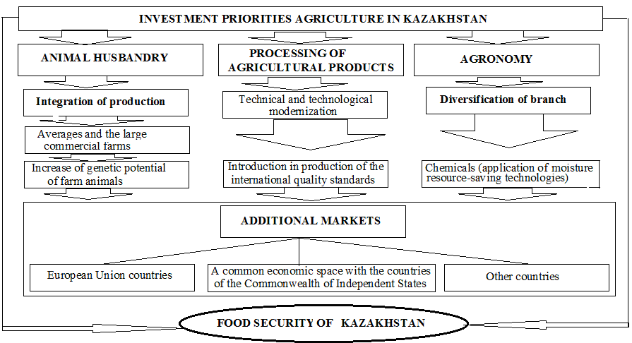

Figure1: (Ms. Temirbulatova, 2015).

Copyright Form
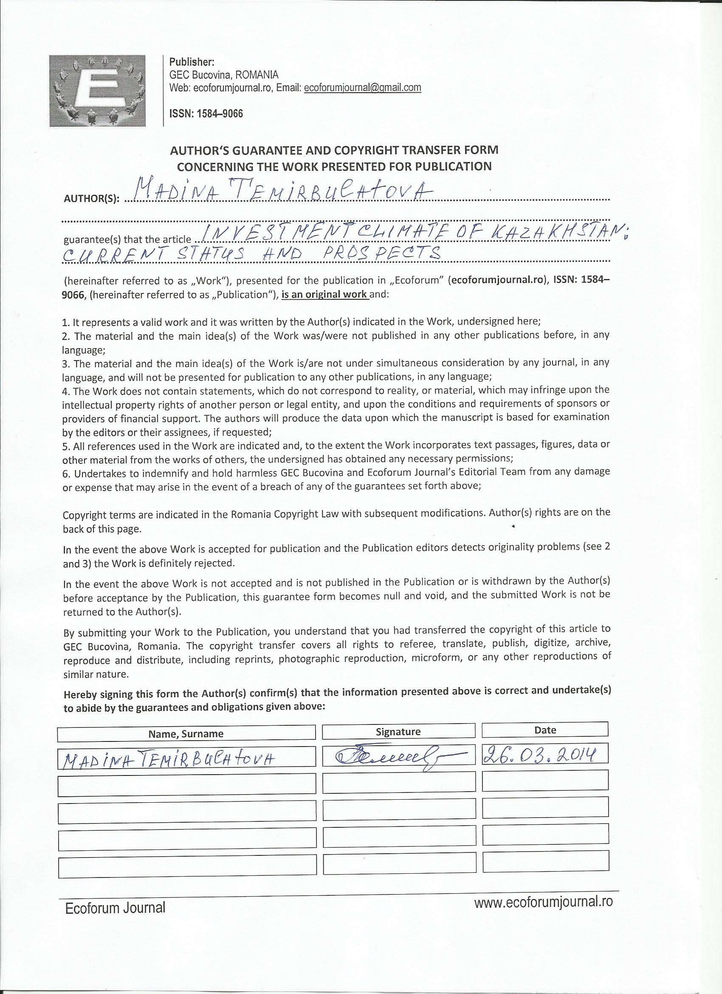

There are some large perspective segments for investment. It is grain sector, in particular wheat, cultivation in greenhouses, poultry farming, animal husbandry, etc. Today Kazakhstan experiences difficulties in grain infrastructure – outdated elevators and shortage of their capacities, insufficiently developed transport system which doesn't allow to take out large volumes of grain to short terms. All these problems open great opportunities for attraction of direct investments. In general all of them rely on available land assets in the country and on the state support. But thus it is necessary to recognize that many agricultural indicators of Kazakhstan were several times higher in the late eighties – the beginning of the 90th years, than now. It testifies that doors are open for those investments where fixed capital goes not only for acquisition of new assets, but that is more important, on acquisition of modern means and production technologies (Herbada,2013).
Speaking about the investment period and conditions of return of invested funds, projects usually have long term in a portfolio, as a rule, these are 5-7 years thus notable distinctions between grain sector, cultivation of hothouse vegetable cultures, production of oil-bearing crops, animal husbandry, poultry farming, etc. And, of course, a big difference between production and processing. In a case with grain it is about increase in indicators of productivity, storage, logistics and "hedging" to keep production as far as it will allow climate. But, unfortunately, some last years the climate created high volatility everywhere and there is no opportunity to control a rain or weather, however the due management allows to predict financial expenses and to reach results without excessive deviation from the drawn-up plans.
The main difficulties in the sphere of animal husbandry, poultry farming, and also in the food industry consist in operational management of production and dynamics of the market which is in turn shown in opacity, abundance of the import which isn't meeting norms and standards. In Kazakhstan the tendency of division either into very big corporations or on very small farms and as that concept of "average economy" of grain sector doesn't exist is observed. Investment into small-scale enterprises is the uninteresting sphere for the international investors. Partly it is connected with that a basic condition – opportunity completely to influence production exit, using modern means and production technologies. And it can be realized only in the presence of the sufficient scale and the size of the company. That in other countries in the past, so this possession of the small-scale enterprises creating completely cooperative societies extremely well worked. These are such cooperatives or the holding companies which are in joint property. These societies cooperated with institutional investors, keeping, thus, care of a small-scale enterprise of production, but reaching the necessary scale of the production working with modern means.
The policy of subsidizing of agricultural production demands close attention. For today the state invests huge amounts of money for development of agriculture in the form of subsidies, but to give an objective assessment to efficiency of carrying out this policy early enough. In Kazakhstan, unfortunately, public funds aren't always used rationally and on purpose. The president of the country in the official statements emphasized more than once that "only those producers introducing advanced technologies have to receive subsidies grow up demanded agricultural production, culture which it is necessary to us". The businessman receiving from the state of a subsidy often doesn't modernize the production, isn't engaged in increase in outputs, doesn't develop the new lands. However there are also other problems - an illegal intermediary role between the state and the businessman (shadow structures in executive power) in many cases don't allow to bring to the final recipient the support planned by the state (http://www.ia-centr.ru.).
Thus measures of the state support will play the stimulating role.
The government of RK annually allocates the considerable volume of funds which go on:
- Stimulation of cultivation of priority cultures by subsidizing of cost of inventory items.
- The new budgetary program for reduction in cost to 50 percent of cost of the mineral fertilizers acquired by agricultural producers is entered,
- For support of development of seed farming from the republican budget
- Within the anti-recessionary program the government of RK credits subjects of agrarian and industrial complex, including on carrying out spring and field and harvest works.
- For development of new technology and withdrawal from a raw orientation of economy the state carried out tax privileges to a domestic production and domestic science. The research works promoting development of the Kazakhstan production are exempted from the VAT (Cordjaybayeva A,2009,p. 7-8).
- Is provided to exempt from corporate income tax (CIT) of the taxpayers creating the new productions necessary for the country completely. These measures allow increasing competitiveness of a domestic production, to carry out production diversification, to form new industrial clusters. All this will stimulate domestic demand for import-substituting production and ensuring steady increase in production and export of production with own value added.
It should be noted that one of the main directions of attraction of investments into new knowledge-intensive and hi-tech productions is stimulation of updating of the outdated fixed assets provided by the legislation of the Republic of Kazakhstan on the state support of investments. Stimulation of updating of fixed assets is made by providing investment tax preferences in the form of the right for additional deductions from a cumulative revenue of taxpayers, and also release them from payment of the property tax on again entered fixed assets and a land tax on the sites acquired and used for implementation of the specific investment or innovative project (fig. 2).

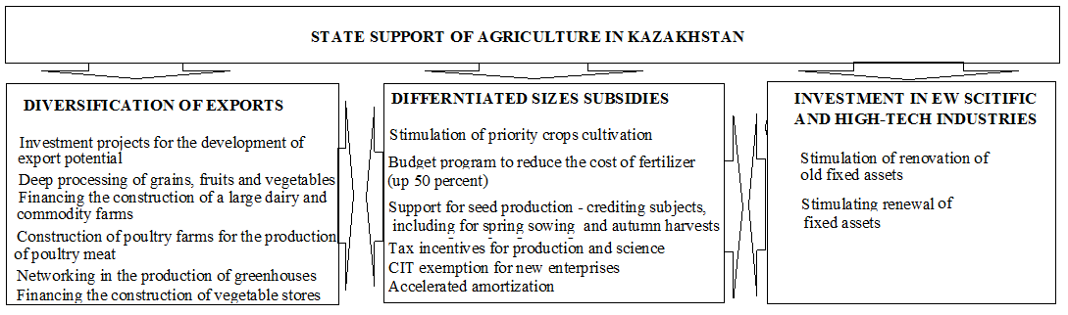

Figure 2: (Ms. Temirbulatova, 2015)

The stimulating factor of investment activity, besides tax privileges the principle of the accelerated depreciation which is based on reduction of terms of depreciation and increase of rates of updating of fixed assets gained distribution in technologically developed countries and in our republic. This approach allows to reduce taxable profit, to increase internal accumulation, strengthening financial stability of the enterprise, reducing the risk connected with commissioning of new equipment.
If to consider already created interstate unions, in this plan it is expedient to consider relationship between Romania and Kazakhstan. It is known that Romania is among the first states which recognized independence of Kazakhstan. Kazakhstan shares aspiration of Romania to establishment of close economic relations and is ready to joint projects in transportation of the energy carriers to the world markets through Romania. In 1998 Bucharest expressed readiness for economic cooperation with the countries of Central Asia and the basin of the Caspian Sea. In turn, Astana then declared the interest in constructive dialogue with Romania in questions of use of a trans-European corridor for transportation and transit of the Kazakhstan freights. The intergovernmental Kazakhstan-Romanian commission on cooperation is already created and began the work. Thus for economic interaction of Kazakhstan and Romania the oil and gas sector, mechanical engineering, agriculture, transport and light industry are considered as the most perspective branches ( kazinform.kz.,2014).
Romania saved up an extensive experience in the sphere of technology of production of hydro carbonic raw materials, creation of the special equipment. Also transit, route opportunities of this country for advance of the Kazakhstan goods to Europe, including oil are important.
Romania wins first place in the region of the Black Sea on the tonnage of the courts which are under construction in a year, first of all, of tankers. Therefore transportation of oil from the Caspian Basin, processing and sending oil products to internal and external consumers are important tasks for successful functioning of the Romanian economy. Romania has not only transport infrastructure and installations on processing of hydro carbonic raw materials. This country at the same time is also a sales market of oil and can become for our country a starting point of distribution of oil products in the region of the Black Sea and Eastern Europe. The special impulse to cooperation in this sphere can give existence at Kazakhstan to need for transit of the oil on the European markets, and Constanta port and the «Friendship Adria» oil pipeline just and are offered by partners from coast of Danube as powerful argument of economic friendship (The European dialogue,2004,p. 87-91).
Kazakhstan and Romania will develop in common electronic decisions in education, medicine and agriculture, about it the Memorandum of cooperation in development ICT (information and communication technologies) in 2014 was signed with the SIVECO Romania Company. E-Learning, electronic agriculture, electronic health care, electronic customs and other projects made a difference for millions of people: from children for whom they opened a way to effective and interactive process of training and teachers, whose works were weakened, that farmers for whom they simplified access to prosperity and the countries which benefit by health system now, organized by means of technology .Among the most noticeable projects of the company are: IT system for National medical the insurance house, IT system for agency on payment and intervention for agriculture, IT system on the basis of education, IT system for National customs authority in Romania, Turkey and Macedonia. Now the company develops projects in Morocco, Azerbaijan, Kazakhstan, Moldova, Cyprus, Kuwait, the United Arab Emirates, Turkmenistan, Serbia, etc. (http://profit.kz/news/11326, 2014).
The expertise in eAgriculture of SIVECO Romania has been formed through the development and implementation of high performing IT solutions dedicated to the agricultural sector in Romania. The IT projects have a huge size and complexity, with outstanding results. Carrying out and implementing these IT solutions has lead to increasing the efficiency in managing the European funds for the Romanian agriculture.
Following the EU accession, Romania has accessed funding programs dedicated to agriculture, aiming at facilitating farmers’ access to any form of financial aid, either internal or external and the step by step fulfillment of the commitments undertaken to EU:
- The Payments and Intervention Agency for Agriculture (APIA), in charge with the funds managed by FEGA
- The Payments Agency for Rural Development and Fisheries (ADPRP), in charge with the FEADR and FEP (European Fund for Fisheries) funds respectively.
In this context, the payment agencies have implemented appropriate IT systems through which they ensure the management and control of the financial aid granted to farmers. SIVECO Romania has specialized in the execution and implementation of IT projects aiming at improving the economic activity through automation of all the processes developed within the specialty services, and has made available its experience and expertise in the IT projects undertaken, both within the National Fisheries and Aquaculture Agency, as well as of the National Land Improvement Agency.
In Kazakhstan communications with inclusion of the earth in market the turn appears need for new financial instruments as mortgage valuable issue papers (bonds). The mortgage mechanism in practice has to be, is realized as follows: the bank forms a covering of own mortgage certificates or mortgage certificates at other banks and carries out release. In this case the property rights to property making a covering, and also all rights and duties following from providing pass to holders of share mortgage bonds. The bank becomes the trustee, and holders of papers become beneficiaries under the contract of trust management. Advantage of the earth as object of pledge, speaks: first, constancy of location and tendency of continuous increase of cost; secondly, the land plot as the put object, remains in possession and use of the depositor who continues to exploit him, gaining income from production and realization of products; thirdly, due to registration of the property right to the land plot, registration of the mortgage, release and the address of the valuable mortgage papers provided with the land plots of agricultural purpose the considerable spare capital in agrarian sector of economy is attracted.
Follows from the European experience of mortgage lending that formation of land and mortgage system happens on the basis of simple models, to participation of the state support. The credit institute provides loans under the credit support of land without mortgage registration and capital issue, with the budgetary compensation of the interest rate on the loan.
A main objective of the initial stage of formation of regional land and mortgage system of crediting is development of credit and financial mechanisms of mortgage transactions further to start the refinancing mechanism. Land mortgage loans are granted on the following purposes: the credits for the purpose of purchase of land (including, land shares); credits for development of an agricultural commodity production (acquisition of agricultural machinery, animals, etc.); credits for improvement of the earth (irrigation, fight against an erosion, etc.).
Conditions of acceptance by bank as proof of the land plot:
• the subject of pledge belongs to the natural or legal person on the property right and makes the area not less than 70 hectares
• the land plot has to be allocated in nature (for districts), which is entered in the unified register of the rights for real estate and transactions with it
• available there have to be documents confirming estimation of cost offered as proof of the land plot, the cadastral plan and the passport of the land plot, etc.
The concept of land mortgage lending is based on buying up by the borrower of land shares, formation of the new land plots and registration of the property right to the bought lands. Such technology of crediting assumes stage-by-stage process of implementation of the mortgage transaction which is carried out according to the following scheme:
• meeting with owners of shares of the land plots which showed willingness to sell the land shares is held;
• the lease contract of land shares is dissolved;
• the land surveying of the new land plot, with assignment of cadastral number is carried out;
• with citizens, owners of shares of the land plots, contracts of purchase and sale of shares of the land plots of agricultural purpose are signed;
- the borrower develops the business plan of the investment project;
• the market assessment of the land plots offered for mortgage providing is carried out;
• the decision on land mortgage lending of the borrower on the security of lands of agricultural purpose is made;
• at the same time, with the state registration of the transaction on acquisition by the borrower of shares of the land plots,
•the state registration of a mortgage of the land plots of agricultural purpose with encumbrance of the rights of the depositor is carried out;
• the Certificate on the state registration of the property right to the land plots of agricultural purpose with encumbrance by their mortgage is granted;
• the issuance of credit on purpose, is carried out through the settlement account of the borrower with confirmation of target use to the final recipient of money.
Thus, in our opinion, these actions will be the main directions of increase of investment appeal of domestic agricultural production which we presented in the form of Model (figure 3).

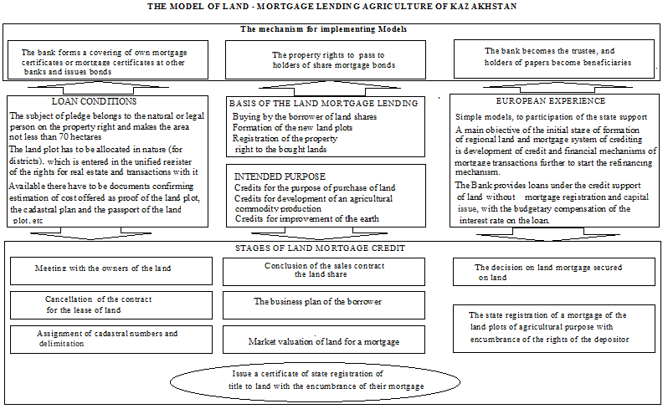

Figure 3: (Ms. Temirbulatova, 2015).

CONCLUsions Now there is unresolved a number of problems in the theory and methodical approaches of increase of economic efficiency of branches of agriculture on the basis of increase of their investment appeal that demands careful studying of questions of formation of mechanisms and search of the most priority directions of increase of investment appeal. Considering a question of involvement of the investor, it is necessary to analyze structure of the capital of the company, in particular, a ratio of borrowed and own funds. The structure of the capital has impact on results of financial and economic activity of the enterprise. The ratio between own and loan sources of means is one of the key analytical indicators characterizing degree of risk of investment of financial resources into this enterprise. Usually, at normally functioning company, according to the western technique, the coefficient of a ratio of borrowed and own funds makes ranging from 1 to 3. It means that the ratio of own means to the general assets has to exceed 25%.
The analysis of investments into fixed capital of agriculture with the developed market economy shows that the specific weight of own means has to make 65-70% (including profit of 40-45% and 25-30% depreciation charges).
Making use of experience of the states of the European Union, in structure of investment of fixed capital of agriculture it is offered to increase a share of own means by 2015 to 75%, including arrived - to 35%, depreciation of-40%, foreign investments of-6%, loan-11%. Each object needs to solve all complex of modern problems of production at the expense of the allocated investments: economic (production of competitive and highly effective production), ecological (guaranteeing environmentally friendly environments, emissions and dumplings of harmful ingredients in the minimum maximum permissible concentration), technological (application of the high waste-free, low-waste and environmentally friendly technologies guaranteeing release of high-quality production of new generation).
At the same time due to the same investments it is necessary to improve structure of production of goods for the solution of social problems, eliminations of disproportions between primary branches of production of goods and infrastructure branches (rural farms, transport, communication, power, etc.). As well as in other areas, integration of agricultural HIGHER EDUCATION INSTITUTIONS with the agrarian and industrial complexes enterprises where the enterprises have to lay down the conditions and requirements to the employed experts has to practice in the sphere of agriculture the increased rates. And HIGHER EDUCATION INSTITUTIONS, meanwhile, should establish stable relations with the agrarian and industrial complexes enterprises, to sign contracts for target training of specialists in which possibility of practical training has to be provided, of training, receiving a grant at the expense of future employer, in a word – to create opportunities and conditions for improvement of knowledge and skills of future expert. The weak preparation of professional shots which is the reason of training on the basis of an outdated educational program, shortage of innovative methods and technologies of training demands the permission by means of the corresponding investments, after all investments into agrarian science are many times more effective than direct investments in agriculture. On this occasion high-quality break concerning technological modernization is required – the contribution to development of domestic, advanced system of agrarian researches, and also control and monitoring of their realization is necessary.
As shows world experiment, restructuring of economy is impossible without carrying out the purposeful state scientific and technical, industrial and investment policy stimulating development of hi-tech and knowledge-intensive productions. Kazakhstan has all prerequisites taking the leading positions as the main supplier of foodstuff on the Central Asian region. In order that investments into the Kazakhstan economy became profitable, it is necessary: to minimize inflation - to 6% and less in a year; to unblock financial resources of the agro enterprises — current assets, depreciation charges, arrived; to develop the stage-by-stage system of the state protectionism directed on maintenance and development of infrastructure branches of economy, production with the high technologies and technologies providing competitiveness of a domestic production in the world market. Therefore, the stimulating factor of investment activity are tax preferences, the accelerated depreciation, state regulation and support by subsidizing, stimulations of a domestic consumer demand, the state order, etc. The measures undertaken by the government of Kazakhstan allow to create necessary conditions for development of effective competitive agro-industrial production, expansion of export opportunities and increase of a standard of living and welfare of country people. Growth of agricultural production will be provided by increase in outputs and sales in the internal and external markets of competitive production.

Tables, Figures, Equations

Figure 1 – Investment priorities agriculture in Kazakhstan

Figure 2 – State support of agriculture in Kazakhstan

Figure 3 – The Model of land-mortgage lending agriculture of Kazakhstan

References

1. Amenova S.S., Akylbayev M. S. Magazine: Theory and practice of innovative management: native and foreign experience, Karaganda, 2013
2. Ambassadorial hour Vasyl Soar — the Plenipotentiary ambassador of Romania in RK//the European dialogue. — 2004. — No. 1. — Page 87-91.
3. Cordjaybayeva A. Tax privileges in a native production and domestic science//Economy and the right of Kazakhstan, 2009, No. 15, page 7-8.
4. David Herbada, Business weekly "Kapital.kz" of http://kapital .kz/expert/31191/summa-neobhodimyh-investicij-v-selskoe-hozyajstvo-rk-sost
5.HON Evgeny, With "KURSIV", No. 28 (454), Almaty, 2012 of p. 11

6.Problems of agrarian and industrial complex of Kazakhstan: and things are right where they started//Information and analysis center. http://www.ia-centr.ru. 25.08.2014.
7. Questions of trade and economic cooperation of Kazakhstan and Romania were discussed by presidents of two countries//kazinform.kz.,2014.
8.http://profit.kz/news/11326/Kazahstan-i-Ruminiya-podpisali-memorandum-o-sotrudnichestve-v-oblasti-razvitiya-IKT/

