Creating a Market of Property Rights: The Case of Czechoslovak privatization

Author 1
Author 2

Abstract
Year 2016 marked the 25th anniversary of an introduction of the main measures of the Czechoslovak transformation process, which moved the country from a centrally planned economy towards a free market economy. Approach to the transformation varied among economists, who promoted two main ways of transformation – slow-paced gradualist approach and fast, decisive turn towards capitalism, which prevailed in the society. The paper sums up four main pillars of the Czechoslovak transformation: liberalization of prices and international commerce, macroeconomic stabilization and re-allocation of property rights. The focus is placed on a creation of a market with property rights through privatization and a restitution process. The last part of the paper describes macroeconomic development of transforming Central European countries and concludes that Czechoslovakia fared the best in inflation and unemployment while suffering not as deep drop in output as other countries.

Key words: Czechoslovakia, economic transformation, free market, central planning, property rights

JEL Classification: P10, P20, K11

Introduction
For more than four decades since 1948, the Czechoslovak economy was a directive system, modeled after the Soviet example. In theory we characterize such economy by terms centrally planned, bureaucratically managed, administrative, directive, or as an economy of permanent shortage of basic consumption goods. The decision-making was done by the Central Planning Bureau, which was directed in a manner of political demands. The oppressive regime was torn down in 1989 during the so-called “Velvet Revolution” and it was replaced by democratic institutions (Wheaton, 1992). Hand in hand with groundbreaking changes across all “Eastern Bloc” countries, there was a desperate need for reconstruction of inefficient social and economic system and introduction of new democratic features, rule of law and free-market capitalism. The path towards prosperity was not straightforward and clear and many countries had to make their way in very complicated conditions. Also, not all countries in the transformation process were as successful as others. Even the case of Czechoslovakia had its bumps along the road, as the country split into Czech and Slovak Republics in 1993 with all problems of economic separation.
Now, exactly twenty-five years later after the main economic measures and steps taken towards capitalist economy, the Czech Republic and the Slovak Republic are economically flourishing countries in the Central Europe, members of OECD, EU and NATO. This humble paper tries to discover and delineate main institutional changes, which made the Czech Republic the most economically successful country of all former communist countries in Europe.

Starting points of the transformation
In the 1980´s, the Czechoslovak economy was not in a good shape compared to other countries of the Eastern Bloc. Invasion of the Warsaw Pact armies to Czechoslovakia in 1968 effectively suffocated all attempts to liberalize the economy. Contrary to other socialist countries, there were no economicreforms for more than forty years, which would promote at least small private ownership and business. This conservativism under central planning resulted in massive state ownership of basically all capital goods, ranging from large utility companies to small businesses (including services, restaurants and local grocery shops) and significant share of housing. As a result, more than 95 % of all economy was state-owned. (Zeman, 2015) No other transforming country had such a heavy heritage of nonexistence of property rights. The stunted development of institutions granting property rights was one of the biggest problems of Czechoslovak economic transformation.
Hand in hand with the state ownership and limited property rights, the price mechanism did not work properly. Wholesale and retail prices were set by the central plan and depended almost entirely on political objectives. This allowed giant redistribution channels of value added between single products as well as whole industry branches (losses in one industry were compensated by another industry - profits or market incentives were not considered). Letting prices get right was another task of the transformation. The change of ownership rights and their decentralization was also connected to possible problems on the labor market. Socialist countries had “zero unemployment policy”, under which the existence of unemployment was unacceptable. This system was very inefficient, creating disincentives to work effort and adversely affecting work ethics. (Klaus, 1995)

Different approaches to the institutional change
The pace of the institutional change is a crucial parameter in its success. The transformation process was not a natural change with all agents acting on their own, even though we might consider it being an evolutionary one (inefficient central planning was replaced by free market). Contrary to the common view, the new reality of centrally planned economic system falling apart was not a surprise for many Czechoslovak economists. The initial point of the institutional change was set clearly by state of the economy in late 1980’s. The end-point of transformation process as well as speed and depth of transformation depended on public debate and political power and will of elected lawmakers and members of government.
The major group of “free-market liberalists” confronted ideas of directive system with current foreign literature and foresaw the collapse of the socialist management of economy as inevitability. The group later gravitated around professor Vaclav Klaus, who later on became the Minister of Finance and Prime Minister in the transition period and posed as a strong political leader with rigorous economic program. His group of the same-minded economists developed key concepts of transformation in the 1980’s and brought their ideas forward very fast in the revolutionary period. Ideology of “free-market economists” was founded on key concepts of modern schools of economics thought (monetarism, libertarianism, public choice). Politically, they drew inspiration from period of Reaganomics and government of Margaret Thatcher in the Great Britain. In their view, the change towards the free market economy could not be separated from reinstating all basic political liberties, which would grant maximum freedom to each member of the society. The change had to be done in a swift way with detrimental effects (drop in product, spike in prices) isolated only in the initial period. The idea was to set up the market first and parallel to the creation of market the legal system would be constructed (Klaus, 1991; 1992; 1995; 1997). For its speed the idea is now called the “shock therapy”.
The other approach was a “gradualist approach” or “gradualism”. The deep institutional change in the economy was accepted as an intended end, but contrary to “shock therapy thought”, the path to the end-state would be much slower. The gradualist approach took legal system and rule design as a priority to creation of a market. The main idea was to implement legal principles, which would stem mainly from Western-European legal codes, and only after when the field is set and the rule book is written, the “chaotic” market could be introduced. Pace of individual steps caused many collisions among supporters of gradualist approach and gave shock-therapists the upper hand (Holman, 2000).
The division between supporters of fast paced, radical change and “gradualists” (which is in many fields not a clear-cut one) outlined the economic debate in the early 1990’s and affects public and academic debate about economic transition in the Czech Republic up to this date. The race for power to design institutional change had a clear winner - supporters of fast transformation.
Although successful, the “shock therapy” was not applied in in a fully libertarian sense (Tříska, 1992). The main steps towards the establishment of property rights and market mechanisms were taken very fast, but some other steps towards full liberalization of took some time or have not been (and probably never will) be implemented (ambitious and market-conform plans for introduction of university tuition, private social and health security etc.). Question of speed and smoothness of transformation with no intermediary steps and stalling on one stage of institutional change seems as a keypoint of willingness to bear costs and suffer discomfort (like price instability, diminished saving due to inflation, drop in the national product and private real income etc.) fades in the society over time. Another positive aspect of fast paced changes was the elimination of (at least partly) corruption pressures and asset stripping in state-owned companies during the “vacuum” period. This commonly occurred in other transforming countries, where steps towards re-allocation of property took longer.

The four main pillars of economic transformation
- Process of economic transformation in Czechoslovakia was based on four main macroeconomic and microeconomic pillars:
- Introduction of private ownership and massive transfers of state property to private owners;
- Liberalization of regulated domestic prices;
- Liberalization of international trade – de-monopolization commerceand external convertibility of currency;
- Macroeconomic stabilization.
The price liberalization was based on removing main distortions in the pricing system and removing a system of subsidies across products and industry branches. The major body of prices was liberalized effective to January 1991. Because of the threat of hyperinflation, the restrictive policy was introduced to keep the inflation in check. Until 1991 there were 3 types of prices: centrally set prices, centrally regulated prices and non-regulated prices.
Foreign trade liberalization, effective from 1991, was based on the abolition of international trade monopoly held by state owned commercial enterprises. Czechoslovak crown (CZK) was pegged to a basket of foreign currencies and initial exchange rates (mainly to USD) were arbitrarily set by the governemnr. Czechoslovak crown became internally and externally convertible and Czech goods and services (which were outdated and in many cases uncompetitive Western production) were put to the test on the free market.
Macroeconomic stabilization leaned on transformation of the bank system from the single level to the double-layer model (Czechoslovak National Bank and privately-owned commercial banks).The Ministry of Finance and the central bank fine-tuned macroeconomic aggregates to keep the inflation in check and aimed to lower detrimental effects of re-focusing of the national economy to new markets. This restrictive policy lead to the most positive outcomes of all transforming Eastern European countries, as it is shown later in the paper.

Changes in property rights and ownership of capital goods
Institution of property rights and its legal enforcement is a fundamental condition for a well-functioning market economy (Scully, 1988; Williamson, Kerekes, 2011). To make the market work and economy to flourish, a clear allocation of property rights is needed. In developed economies, we usually do not have a problem with design of the “time zero” property rights distribution as there is a long history of property entitlements and property market institutions. In a country, which is transforming from totally different economic system to a free-market economy, the “time zero” distribution is a crucial point - slight differences in its design can lead to success or failure of the whole transformation project.
Czechoslovak mass privatization and restitution led to the re-distribution of over 95 % of formerly centrally planned economy through newly set up government institutions and courts of justice (Zeman, 2015). It was a unique process in a history not only by its extent but also by its impact on population. The privatization process with its numerous risks was an irreversible step towards transformation of the whole country towards capitalism and free market. Steps taken towards the privatization reflected lacking disposable domestic capital means for investment, which were after four decades of communism almost none, and tried to set the fairest base for original allocation of property rights among economic agents, as it was possible in the context of the early 1990’s. In many regards it was a large-scale natural experiment in building viable free market and property rights institutions from ground up.
Contrary to Western European countries, Czech or Czechoslovak property rights were not very stable and were re-allocated in almost every generation during the past hundred years. The long-term instability in the area of property rights can be shown mainly in agriculture and forestry, where most of property (land and forests) had changed its owner ex officioat least five times from 1918 up to the present (due to legislative and legal changes) (Zeman, 2015). Private activity, inherently connected to private ownership, diminished as well as other social norms and institutions (morality, ethics, work enthusiasm). Czechoslovak case was an extreme scenario even in the Eastern Block. For example Hungary in the period from 1960’s until 1980’s strengthened small business sector, cooperatives and joint-venture companies. Poland also maintained relatively large private sector, especially in agriculture and retail. German Democratic Republic (GDR) maintained a significant private sector and became the most innovative part of the Eastern block (even though it lagged behind its Western neighbors). Even in comparison to the Soviet Union, Czechoslovakia had lower share of private sector. The state seized vast majority capital means of production and other property. Due to this problem, Czech people suffered from shortage of disposable capital for investment as well as know-how how to do business during the time of transformation (Sucháček, 2011).

Table 1: Czechoslovakia/Czech Republic: Share non-public sector (% of GDP)
Year | 1990 | 1993 | 1996 | 1999 | 2002 | 2005
Share of non-public sector | 12,3 % | 45,1 % | 71,7 % | 76,4 % | 79,7 % | 80,5 %
Source: Sucháček, 2011

The government tackled the problem of the original allocation of property rights in various ways. The main parts of ownership changes consisted of:
- Privatization process (paid transfers of property),
- Restitution process (return of property to former rightful owners or their heirs – either
in natura or in a form of financial compensation),
- Dismantling of state-owned enterprises (division or controlled bankruptcy) and
- Decentralization of state ownership to municipal ownership.
Change of forms of ownership in Czechoslovakia was, due to its vast consequences, very demanding in cooperation of executive, judiciary and legislative branches of government as well as the developing financial system, which supplied resources for investment.
The most successful part of ownership changes was the process of privatization. The privatization process was divided in two main projects- small scale privatization and large scale privatization.
The objective of the small-scale privatization was to sell small commercial property like service vendors, shops and retail, accommodation and restaurants, tourism etc. to common public and to promote private enterprise. The main vehicle how to sell out the state property was a public auction. The point of public auctions was not to discriminate in the privatization process, even though the Czechoslovaks had advantage as first round of public auction was always closed to foreign entities. The reason behind this political decision was that Czechoslovak entities were disadvantaged owing to relatively small resources for the purchase of auctioned business and could be rolled over by speculative foreign capital. The entire process of small-scale privatization was being prepared during the second half of 1990, and was effectively exercised between 1991 and 1993.
Large-scale privatization used standard and nonstandard methods. Standard methods used in this part of privatization were mainly public auctions, public tenders, direct sales, transformation a state enterprise to a joint-stock company. The majority of assets in public auctions and public tenders were purchased by domestic entities (about 0.5 % of property in tenders and auctions was sold to foreign entities).The vast majority of the property, which was privatized in direct sales was also purchased by domestic buyers (47 billion CZK domestic, 5 billion CZK foreign buyers). Different situation was in direct sales of shares – out of 454 billion CZK in total, 349 billion in shares was sold to foreign entities and shares priced at 104 billion CZK were bought by domestic entities (Ševčík, 2010).
The nonstandard method was a voucher privatization. Designers of the voucher privatization took an example in Milton Friedman’s experiment with voucher allocation of tax payments to individual schools. Government offered a “voucher book” for purchase to general public. Each citizen of Czechoslovakia could purchase one voucher for 1000 Czechoslovak crowns (roughly 1/3 of average monthly pay). Consequently, the buyer could exchange the voucher at a market “price” for a share in any of privatized companies. New market prices were published in newspapers and people started to take care about developments in the financial market. Disadvantage of this method was that general public had very shallow (if any) understanding of capital market. Many people took their chance and considered this instrument more as a lottery game. In all cases, voucher privatization gave everyone a fair chance to invest in publicly traded companies and helped to develop Czech capital market, although some got more successful than others.

Table 2: Overview of the Privatization (Total assets privatized up to 31. 12. 2010)
The number of privatized property transfers | 886 778
Total privatization revenue | 821,8 billion CZK
Total privatization revenue as share of GDP (1990) | 30,1 %
Source: Zeman, 2015.

Assessment of the transformation
To put outcome of the Czechoslovak and Czech transformation to a test, we compare basic macroeconomic indicators among the Central European transforming countries. Changes in product (measured in real prices), unemployment and inflation were key variables which each government tried to keep in check. We compare the Czech Republic head to head with the Slovak Republic, Poland, Hungary (both countries applied gradualist approach) and Slovenia. In graphs we compare longer period from 1990 to 2014 in order to describe fitness of economies over time, tables show the most important data of the privatization process up to 2000.

Economy output
Output of the economy, measured in GDP, is the most analyzed and discussed economic aggregate. The problem of transforming countries was mainly in uncompetitiveness of domestic production and high imports at Western-European prices as well need for structural re-orientation of production and commerce to the new branches of industry and finding ways to new markets.
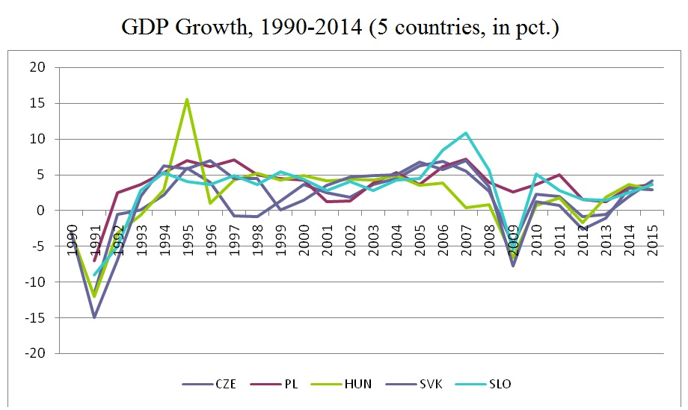
Figure 1: GDP Growth, 1990-2014 (5 countries, in pct.)
Source: Ševčík, 2010; World Bank Group.

All surveyed countries of the former Eastern Block in the early 1990’s witnessed a significant drop in their GDP growth rate. Poland in the period from 1990 to 2000 realized the highest average growth. Even during the economic crisis in 2009 the Polish economy grew (unlike other surveyed countries). Czech Republic experienced a currency crisis in the period 1997-1998, which ended the transition from fixed to floating exchange rate, reflected in decrease of GDP (Holman in Klaus et al., 2010).

Table 3: GDP Growth (1990-2000, selected countries, in pct.)
GDP growth (1990-2000)
 | CZE | PL | HUN | SVK | SLO
1990 | NA | NA | -3,0 | -3,0 | NA
1991 | -11,6 | -7,0 | -12,0 | -15,0 | -9,0
1992 | -0,5 | 2,5 | -3,1 | -7,0 | -5,0
1993 | 0,1 | 3,7 | -0,6 | 1,9 | 2,8
1994 | 2,2 | 5,3 | 2,9 | 6,2 | 5,3
1995 | 5,9 | 7,0 | 15,5 | 5,8 | 4,1
1996 | 4,0 | 6,2 | 1,0 | 6,9 | 3,6
1997 | -0,7 | 7,1 | 4,3 | 4,4 | 4,9
1998 | -0,8 | 5,0 | 5,2 | 4,4 | 3,6
1999 | 1,3 | 4,5 | 4,2 | 0,0 | 5,4
2000 | 3,6 | 4,3 | 4,9 | 1,4 | 4,4
Average | 0,4 | 3,9 | 2,2 | 0,9 | 2,0
St. dev. | 4,528 | 3,868 | 6,641 | 6,557 | 4,656
Min | -11,6 | -7,0 | -12,0 | 1,6 | 4,7
Max | 5,9 | 7,0 | 15,5 | 19,2 | 14,4
Source: Ševčík, 2010; Eurostat.

Inflation
Table 4 shows that all surveyed countries experienced significant increase in inflation connected to price deregulation in the first period of transformation process. Slovenia in early 1990’s experienced three consecutive years associated with hyperinflation. In Poland inflation reached 567,9%in 1990. Czechoslovakia, which fared the best among transforming countries due to its sound restrictive policy, reached a peak in inflation in 1991, when inflation hit its maximum at 56,6 %. Czechoslovakia and later on Czech Republic suffered the lowest average price increase of 13,8%in a decade from 1990 to 2000 of all surveyed countries.

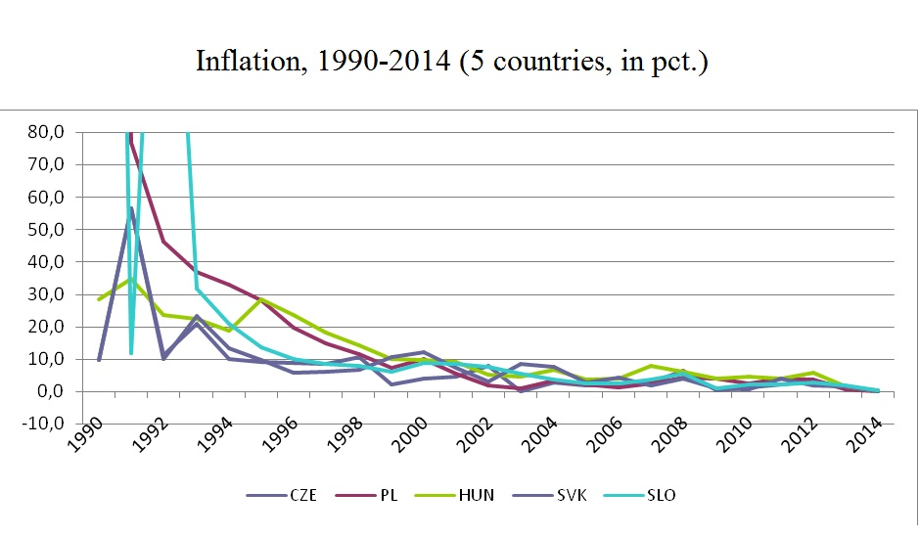
Figure 2: Inflation, 1990-2014 (5 countries, in pct.)
Source: Ševčík, 2010; Eurostat.

Table 4: Inflation (1990-2000, selected countries, in pct.)
Inflation (1990-2000)
 | CZE | PL | HUN | SVK | SLO
1990 | 9,7 | 567,9 | 28,4 | 9,7 | 552,1
1991 | 56,6 | 76,8 | 34,8 | 56,6 | 114,8
1992 | 11,1 | 46,1 | 23,7 | 9,9 | 209,9
1993 | 20,8 | 37,0 | 22,5 | 23,3 | 31,8
1994 | 10,0 | 33,0 | 18,9 | 13,4 | 21,0
1995 | 9,1 | 28,0 | 28,3 | 9,8 | 13,5
1996 | 8,8 | 19,8 | 23,5 | 5,8 | 9,9
1997 | 8,5 | 14,9 | 18,3 | 6,1 | 8,4
1998 | 10,7 | 11,6 | 14,2 | 6,7 | 7,9
1999 | 2,1 | 7,2 | 10,0 | 10,6 | 6,2
2000 | 3,9 | 9,9 | 9,8 | 12,0 | 8,9
Average | 13,8 | 77,5 | 21,1 | 14,9 | 89,5
St. dev. | 14,267 | 156,278 | 7,498 | 13,961 | 158,384
Min | 2,1 | 567,9 | 9,8 | 6,1 | 552,1
Max | 56,6 | 7,2 | 28,3 | 56,6 | 6,2
Source: Ševčík, 2010; Eurostat.

Unemployment
Labor markets of post-communist countries experienced a huge shock as the work paradigm changed paradigm. "The obligation to work" was replaced by an "opportunity" to work. In this regard workforce of every examined country faced a significant change. The biggest problems of long-term unemployment were seen in Poland and Slovakia (where unemployment is a persistent problem, Slovakia has an ongoing problem with the inclusion of the Roma minority in the labor force). The Czech Republic had the lowest average rate of unemployment in all surveyed countries.

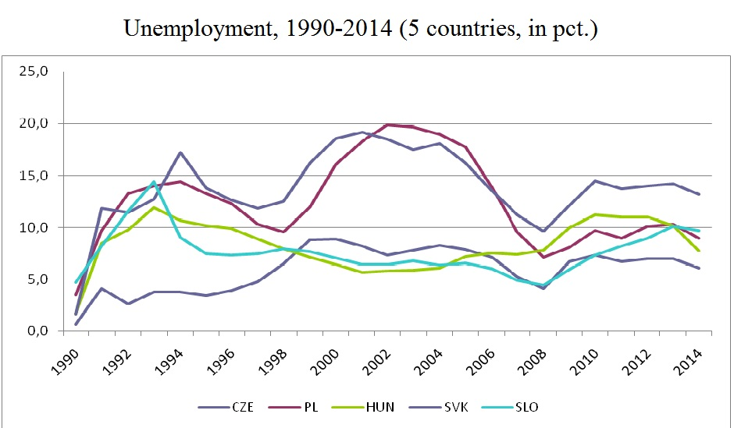
Figure 3: Unemployment, 1990-2014 (5 countries, in pct.)
Source: Ševčík 2010, Eurostat.

Table 5: Unemployment (1990-2000, selected countries, in pct.)
Unemployment (1990-2000)
 | CZE | PL | HUN | SVK | SLO
1990 | 0,7 | 3,5 | 1,7 | 1,6 | 4,7
1991 | 4,1 | 9,7 | 8,5 | 11,8 | 8,2
1992 | 2,6 | 13,3 | 9,8 | 11,4 | 11,5
1993 | 3,8 | 14,0 | 11,9 | 12,7 | 14,4
1994 | 3,8 | 14,4 | 10,7 | 17,2 | 9,0
1995 | 3,4 | 13,3 | 10,2 | 13,8 | 7,4
1996 | 3,9 | 12,3 | 9,9 | 12,6 | 7,3
1997 | 4,8 | 10,3 | 8,9 | 11,8 | 7,4
1998 | 6,5 | 9,6 | 7,9 | 12,5 | 7,9
1999 | 8,8 | 12,0 | 7,1 | 16,2 | 7,6
2000 | 8,9 | 16,1 | 6,4 | 18,6 | 7,0
Average | 4,7 | 11,7 | 8,5 | 12,7 | 8,4
St. dev. | 2,34 | 3,24 | 2,63 | 4,2 | 2,4
Min | 0,7 | 3,5 | 1,7 | 1,6 | 4,7
Max | 8,9 | 18,3 | 11,9 | 19,2 | 14,4
Source: Ševčík 2010, Eurostat.

Conclusion
The aim of the paper was to describe groundbreaking changes in institutional organization of the Czechoslovak and Czech economy after the fall of the centrally planned socialist system of the state-run economy. We have learned that fast-paced changes lead to positive outcomes in example of transforming a state-run economy. Fast and radical approach could pose as a role-model scenario for countries in a point of transformation towards the free-market. The Czechoslovak transformation was based on ideas of fairness and equal chances to invest or start a business. Compared to methods used in other countries, radical change towards the free-market helped to eliminate corruption and asset stripping in state-owned companies, even though there were cases of such malpractice.
It is up to the new generation of economists to critically evaluate the transformation processes in its full scope and learn lessons from such a radical change of economic and social system. As fractures and disruptions in current capitalist economies – especially in the EU and the USA - grow more significant and more visible than ever, we might expect there be a need for re-transformation of today’s economies into original state of free-market in proximate decades.

Acknowledgment
The publication of this paper was supported /name of a grant/. We greatly appreciate this support.

References
- Holman, R. (2000). Transformace české ekonomiky: v komparaci s dalšími zeměmi střední Evropy (Vyd. 1). Praha: Centrum pro ekonomiku a politiku.
- Holman, R. (2000). Měnová krize 1998 byla trest za nezavedení volného floatingu. In: Klaus, Vet al. (2000). Tři roky od měnové krize: sborník textů č. 5/2000. Praha: Centrum pro ekonomiku a politiku.
- Klaus, V. (1991). Ekonomická věda a ekonomická reforma: statě, eseje. Praha: Gennex & Top Agency.
- Klaus, V. (1992). Dismantling socialism: a preliminary report : a road to market economy II = Demontáž socialismu : předběžná zpráva : cesta k tržní ekonomice II. Praha: TOP Agency.
- Klaus, V. (1994). Rebirth of a country: five years after ; collection of speeches of the Prime Minister of the Czech Republic (1. ed). Praha: Ringier ČR.
- Klaus, V. (1995). Ekonomická teorie a realita transformačních procesů. Praha: Management Press.
- Scully, G. W. (1988). The Institutional Framework and Economic Development. Journal of Political Economy, 96(3), 652–662.
- Sucháček, J. (2013). Transformace v České republice z institucionálně-regionální perspektivy. Praha: Národohospodářský ústav Josefa Hlávky.
- Ševčík, M. (2010). Economic policy: the process of transformation and its costs. Praha: Oeconomica, University of Economics in Prague.
- Tříska, D. (1992). Political, Organizational and Legislative Aspects of Mass Privatization – Czechoslovakia, in Privatization in Central and Eastern Europe, ed. by Marko Simoneti and Andreja Böhm. C.E.E.P.N.
- Wheaton, B. (1992). The Velvet Revolution: Czechoslovakia, 1988-1991: Czechoslovakia, 1988-91. Boulder: Westview Press.
- Williamson, C. R., & Kerekes, C. B. (2011). Securing Private Property: Formal versus Informal Institutions. The Journal of Law & Economics, 54(3), 537–572.
- Zeman, K. (2015). Analýza privatizačního procesu v České republice. Praha: Univerzita Karlova i Praze.
- Zeman, K. (2016). Analýza restitučních procesů v České republike: restituce a ostatní procesy transformující vlastnická práva. Praha: Univerzita Karlova v Praze.
- Eurostat (2016). Unemployment by sex and age – Annual average,” Eurostat, http://appsso.eurostat.ec.europa.eu/nui/show.do?dataset=une_rt_a&lang=en, accessed August 22, 2016,
- Eurostat (2016). HCIP – Annual Data,” Eurostat, http://appsso.eurostat.ec.europa.eu/nui/show.do?dataset=prc_hicp_aind&lang=en, accessed August 22, 2016.
- World Bank Group (2016). World Development Indicators – GDP Growth,” http://databank.worldbank.org/data/reports.aspx?source=2&series=NY.GDP.MKTP.KD.ZG&country=CZE#, accessed August 22, 2016.

GDP of the Czech Republic: 2010 - 3 953 billion CZK; 1990 - 2 730 billion CZK.

