HOME CURRENCY PEGGED INTO EURO – POSSIBLE SOLUTION FOR ROMANIAN’S ECONOMY
Dr. Narcisa Roxana Mosteanu
American University in the Emirates, Dubai, UAE
narcisamosteanu@yahoo.com
narcisa.mosteanu@aue.ae

Abstract
The stable exchange rate is very important in international trade. This paper aims to show how exchange rate facilitate the economic growth and all economic conditions of a country, within the time 2008 – 2016. This paper is aimed to be unique because will study the effect of exchange rate on sustainable development, giving a special attention to those countries which have their home currencies pegged into Euro. Conducting the research on foreign exchange regime, it appears that are may papers related to pegging the currency into US dollar, but none to focus on pegging the exchange rate into Euro. The research developed revealed that there are three cases: countries which have their currency pegged into Euro and they are member of European Union (Bulgaria and Denmark); countries which have their currency pegged into Euro but they are still not member of European Union (Bosnia and Herzegovina); and, countries which are member of European Union but they don’t have their currency pegged into Euro or any other international currency (Czech Republic, Hungary, Romania). The analysis was conducted based on official data and find that there is a very strong connection between exchange rate and annual growth, inflation, balance of payment, foreign investments, and unemployment.

Key words: currency pegged; exchange rate regime; economic growth; inflation; unemployment.

JEL Classification: E58; F16; F31; F43; G28

Introduction

This work paper aims to analyze the impact of pegging the currency to Euro have on a country’s economic development, especially for countries part of Europe. This paper comes to be the first one which analyses the crucial reason why the European currencies is better to be pegged to Euro. For countries from Europe, part or candidate to be part of European Union which don’t have Euro as a national official currency, pegging the exchange rate in Euro is a good strategy to develop a sustainable economy. European countries which adopted Euro as home currency decided that as their economy become more integrated (European Union), it would be better to avoid the exchange rate movement inconvenience. This was, for several countries the main point for which they adopted Euro, and those which not yet, prefer to peg or have a managed floating exchange rate between Euro and their home currency.

One of the best source from which the students and those who do not have the knowledge necessary to understand finance, however they want to know is Investopedia. Per this site – A country or government’s exchange-rate policy of pegging the central bank’s rate of exchange to another country’s currency. Currency has sometimes also been pegged to the price of gold. Currency pegs allow importers and exporters to know exactly what kind of exchange rate they can expect for their transactions, simplifying trade. This in turn helps to curb inflation and temper interest rates, thus allowing for increased trade.

LITERATURE REVIEW

During international trade countries use a different exchange rate systems: fixed, freely floating, managed float, or pegged. In the modern era, some countries use a pegged exchange rate in which their home currency’s value is pegged to one foreign currency or to an index of currencies. Although the home currency’s value is fixed in terms of foreign currency to which it is pegged, it moves in line with that currency against other currencies (Madura J., 2016).

Several studies have been conducted to analyze and study the effect of exchange rate pegged to one international currency, with fix rate in gold or used in many countries as an official currency – US dollar or Euro. Most of these studies refer them analyze to exchange rates pegged to US dollar (Kimberly A., 2016) and their implications in those countries, the majority from GCC, MENA area and some countries from Latin America. Majority countries from Africa have their exchange rates pegged to Euro.

Most literature presented the meaning of the pegging the local currency into one international currency without a concrete analyze related to the effect on a country economic development, specified only the crucial role of central bank in maintaining the exchange rate the same over the years. Some studies (Ala El Alami, 2013) examined the advantages which countries have because of peg currency, as there is an economic crisis in one country with which the currency has been fixed there could impact on other countries also because of this, and, presented that the transactions which happen with foreign currencies are having an important role in the foreign trade operations which are reflected in trade, international investments, migration and accumulation of capital (Yevchenko, 2010). Some authors analyzed the resistance of the pegged exchange rates over the time (Coudert, V., Couharde, C., Mignon, M., 2012) and present the effect and the reasons for ruptures of exchange rate peg from a new point – the fluctuations in the anchor currency.

Figure no.1.1: Members states of European Union and Eurozone

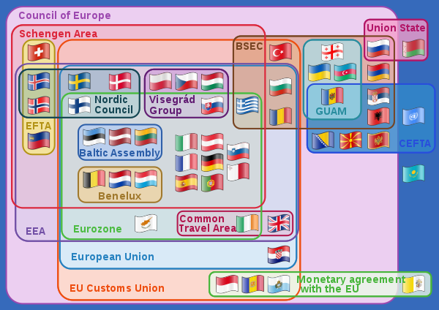

Source: https://en.wikipedia.org/wiki/Member_state_of_the_European_Union

In Europe, pegging the home currency into Euro was done only by Bulgaria and Denmark. These countries choose this strategy to secure their economic future by having a stable currency exchange rate with countries which are the main trade counterparties. These two countries pegged their home currencies into Euro since before the financial crisis and they are still resist on financial markets pressure by adjusting their monetary policy (Codogno L., De Grauwe P., 2015).
.

research methodology

The research objective is to present that currency pegging with Euro have a crucial impact on the economic development of those countries which choose this monetary strategy to maintain and develop their economies. This working paper is aimed to be unique because will study the effect of pegging the exchange rate EURO. From relevancy point of view we choose the period 2008 – 2016, which include the financial crisis span. The research will be focused on the effect of these fixed exchange rates on the economic and social development level.

Based on the research purpose, data would be collected from the public authorities (official website of central banks, ministries of finance, ministries of economics), international relevant financial organizations database (World Bank, International Monetary Fund, European Commission, European Central Bank) and other public database site which are also using data from public institutions presented above.

Research methodology consists in analyzing critical macroeconomic country indicators which are directly correlated to the exchange rate, and in the same time representative for economic and social development framework. These indicators are related to economic growth (GDP), GDP per capita, revenue, total investment, foreign direct investment, the current account balance of payment, unemployment rate, inflation. The qualitative research is the focus in analyzing the data in to demonstrate that currency pegged into one international most traded currency have a crucial impact on each country economic level of development.

data analysis and results

From the very beginning, the research chooses three types of countries: countries which have their currency pegged into Euro and they are member of European Union (Bulgaria and Denmark); countries which have their currency pegged into Euro but they are still not member of European Union (Bosnia and Herzegovina); and, countries which are member of European Union but they don’t have their currency pegged into Euro or any other international currency (Czech Republic, Hungary, Romania). For a better analyze we took the data translated into Euro, for all the countries.

Table no.1.1: Exchange rate, during the period 2008 – 2016 (unites of national currency for 1 Euro)
 | 2008 | 2009 | 2010 | 2011 | 2012 | 2013 | 2014 | 2015 | 2016
Countries which are member of European Union and have their national currency pegged to Euro
Bulgaria | 1.9558 | 1.9558 | 1.9558 | 1.9558 | 1.9558 | 1.9558 | 1.9558 | 1.9558 | 1.9558
Denmark | 7.4604 | 7.4604 | 7.4604 | 7.4604 | 7.4604 | 7.4604 | 7.4604 | 7.4604 | 7.4604
Countries which are NOT YET member of European Union and have their national currency pegged to Euro
Bosnia and Hezegovina | 1.9558 | 1.9558 | 1.9558 | 1.9558 | 1.9558 | 1.9558 | 1.9558 | 1.9558 | 1.9558
Countries which are member of European Union and DO NOT have their national currency pegged to Euro
Czech Republic | 24.946 | 26.435 | 25.284 | 24.149 | 25.149 | 25.980 | 27.536 | 27.279 | 27.034
Hunngary | 251.51 | 280.33 | 275.48 | 279.37 | 289.25 | 296.87 | 308.71 | 210.00 | 311.44
Romania | 3.6827 | 4.2373 | 4.2099 | 4.2379 | 4.4560 | 4.4190 | 4.4446 | 4.4450 | 4.4908
Exchange rate  US dollar/Euro | 1.4708 | 1.3948 | 1.3257 | 1.3920 | 1.2848 | 1.3291 | 1.3285 | 1.1095 | 1.1069

Note: http://appsso.eurostat.ec.europa.eu/nui/show.do?dataset=ert_bil_eur_a&lang=en

From economic growth, research revealed that, during the financial crisis, all these countries experienced a slowdown in GDP, during the year 2009 (Chart no.1). Economic growth and social situation of these countries were affected and this was because also of banking and financial system, the conventional type. In these countries, all transactions between financial institutions, banks, and individuals or companies are charged with an interest. Because the level of interest rate increased, the level of prices was affected (increased) and the level of consumption also (decreased).

The most affected country was Romania (-7.1%), followed by Hungary (- 6.6%). However, based on their specific economic strategic plan, all the country succeeds to recover their slowdown very quickly in 2010 and 2011. Furth more, in 2016, Romania registered the higher annual economic growth (5%), followed by Bulgaria (3.5%) and Hungary (3.0%).

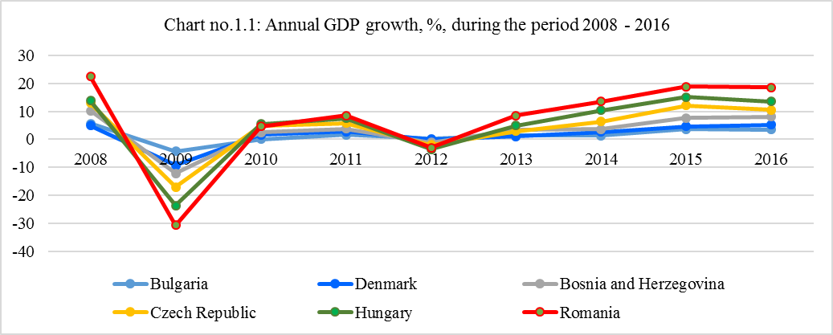

Source: charter determined based on data from http://data.worldbank.org/country;

https://www.imf.org/external/pubs/ft/weo/2016/02/weodata/index.aspx

Looking to the main export partner of these countries (chart no.1.2) it is easily to notice that the main part (50% or more) are from Europe, and they are using Euro as a currency (Germany is one of the biggest export partners) or as a reference for exchange rate. From this perspective having a stable exchange rate regime, even a pegged one become a very good strategy to develop a sustainable economy, maintaining also stability of prices and inflation.

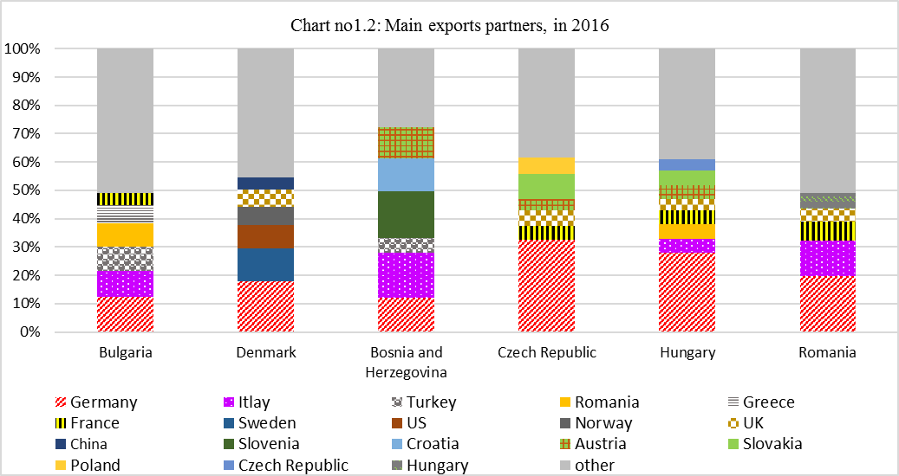

Source: based on figures from https://www.cia.gov/library/publications/the-world-factbook/

In Romania’s case, almost 50% of its export is conducted with countries which are using Euro as national currencies, and from international trade respect, having RON (Romanian national currency) pegged into Euro will be a good strategy to avoid any discrepancy between exchange rates, and keep a sustainable balance of payment.

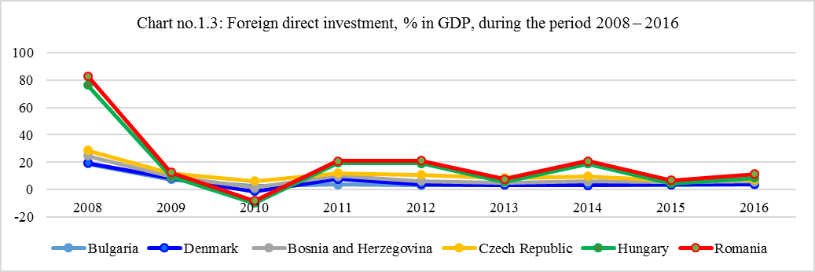

Source: based of figures from http://www.theglobaleconomy.com

For foreign direct investment, as % in GDP, the research noticed (charter no.1.3) that those countries which have their home currencies pegged into Euro have a growth stability rate (Bulgaria, Denmark and Bosnia and Herzegovina), even is the percent is not the highest. The other countries, which don’t have a stable, fixed exchange rate, register higher percent but there is no stability of foreign investment. This instability may cause the low percentage of revenue in GDP and an imbalance in current account of balance of payment.

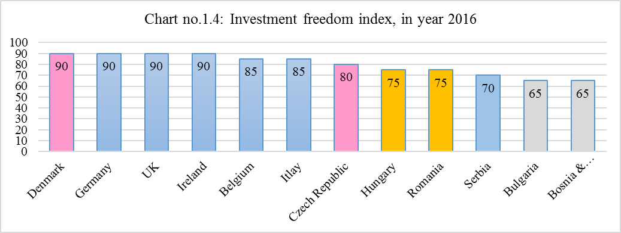

Source: based on figures from http://www.theglobaleconomy.com/rankings/herit_investment_freedom/ (the higher is better)

Evolution of foreign investment is can be also very well represented in correlation with Investment freedom index (Chart no.1.4). The higher value shows that that country id very friendly with foreign investor and already eliminate unnecessary barriers. The country which register lower level means that face a variety of investment restrictions (bureaucracy, restrictions, different level of taxation and compensations between local and foreign investors, foreign exchange rate control) and one of them is exchange rate regime. From the charter above countries which have a fix or pegged exchange rate and less bureaucracy are more welcoming for foreign investors, and foreign investment trend is growing sustainably over the years (Denmark). Countries like Czech Republic, Hungary and Romania have their Investment freedom risk above 75, which means their investment policies is focused on increasing the foreign investment part, offering tax incentives to attract more investors, but the instability of exchange rate and interest rate regime along with bureaucracy make these so be still on the middle place as investment attractions. (From the charter no 1.4 you may see also Italy which register a higher investment freedom index, thus because they are using Euro as national currency, and therefore they eliminate exchange rate risk, but they are still facing issues with bureaucracy and political instability). Countries like Serbia, Bulgaria and Bosnia and Herzegovina, register a lower investment freedom risk than the other analyzed. Possible reason for that can be excessive bureaucracy, and security problems. Points are deducted from the ideal score of 100 for each of the restrictions found in a country’s investment regime.

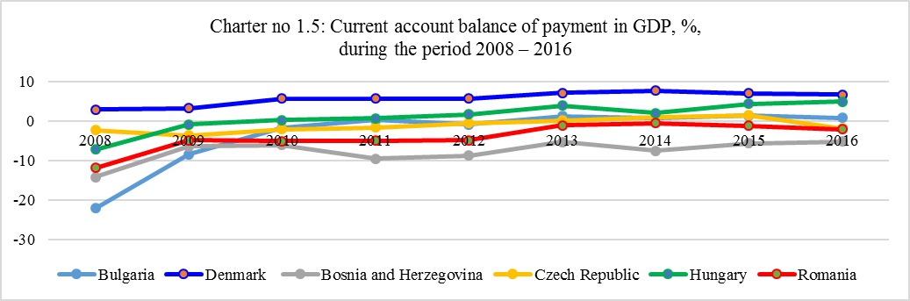

Source: based on figures from https://www.imf.org/external/pubs/ft/weo/2016/01/weodata/index.aspx

Balance of payments shows in a summary the value of transaction between domestic and foreign residents for each country (usually annually data). If the balance of payments records negative data, means that that country inflow of money is less that outflow of money (imports more that exports; or outflow investments are more that inflow investments). The balance of payments of each country is affected by exchange rate between domestic currency and other currency which are used in international trade with their major partners. If a country’s currency begins to rise in a value against other currencies (against Euro in our case) that its current balance of payment will decrease, and good imported by that country will become more expensive. Our research relieved that countries which have their exchange rate (in Euro) stable or pegged register a positive and sustainable balance of payment.

Economic stability has a strong connection with inflation, interest rate and exchange rate. If the exchange rate is kept in fixed or pegged exchange rate regime, then interest rate level will be stable (will not fluctuate to much) and in line with interest rate from that country with which they are keeping fixed exchange rate (in our research the interest rate is aligned with European Central Bank, for Bulgaria, Denmark and Bosnia and Herzegovina. The other countries as Czech Republic, Hungary and Romania have their exchange rate regime as a managed float one, the same with European Central Bank, however they are not necessary align their interest rate level with European Central Bank one). If the interest rate level will remain constant, then the inflation will register lower level, and the price will remain stable.

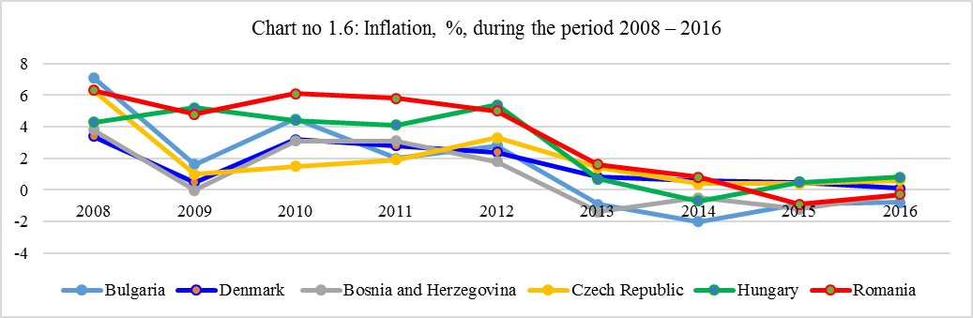

Source: based on data from http://data.worldbank.org/country; https://www.cia.gov/library/publications/the-world-factbook/; http://www.theglobaleconomy.com ; http://world.bymap.org/InflationRates.html

From inflation perspective, our research presented that countries as Denmark and Bulgaria, which have their currency pegged into Euro and align their interest rate level with European Central Bank, register a low level of inflation. Of course, as all the countries form Europe, these two countries were affected by financial crisis (2008-2009), but they recover very quick, and this is also a result of a stable exchange rate regime. Romania and Hungary seems to face severe problems with inflation till 2012. Their economic recovery program gives results after 4 years or economic constrains. If these two countries would have a fixed exchange rate regime and their monetary policy aligned with that practiced in Europe (because the main international trade partners comes from Europe), based on our analyses, it can be considered that the economic recovery would happed much faster than 4 years. Looking to chart no.1.6 we may say that during the period 2008 – 2016, all the countries analyzed were faced inflation, but from different reasons. One common reason is that all of them conduct export and import with countries from Europe, which were affected by financial crisis too.

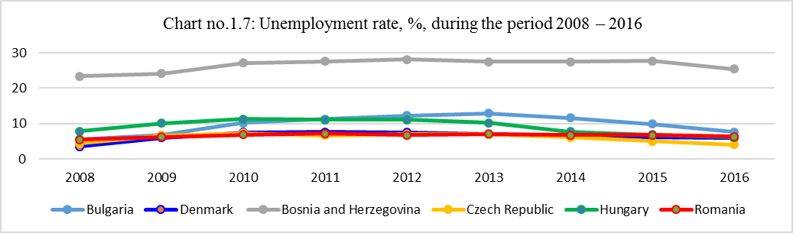

Source: based on data from http://www.theglobaleconomy.com

As it was presented in this paper, exchange rate affect the economic stability and development, and determine the level of foreign investment. Foreign investment will increase if the investors will find stability in financial and monetary legislation. Incensement in foreign investment conduct automatically in opening the new jobs opportunities (decrease the level of unemployment), which will increase the level of revenue and consumption (production also).

From the chart no.1.7. we can see that, even Bosnia and Herzegovina tried to stabilize its economy by pegging their currency into Euro, this still did not help this country to attract more investors and create more jobs. This country is very small and, nearly 20 years after the end of the war, Bosnia and Herzegovina is still divided across two ethnically based political entities — the Republika Srpska and the Federation of Bosnia and Herzegovina. Ethnic tensions shape aspects of life ranging from political affiliation to social circles to employment — or lack thereof. This is the main reason that Bosnia and Herzegovina have a special figure for unemployment level. Denmark and Romania seems to follow the same trend (around 6%), reasons being different: Denmark have their exchange rate pegged into Euro and a constant growth of foreign investment participation into GDP; Romania have a managed float exchange rate into Euro, but it promotes an investment police based on tax (and mandatory social contributions) incentives and public-private partnership. Bulgaria is trying to reduce unemployment rate too, by promoting an investment policy based on low level of tax and special incentives in tourism sector, and having their home currency pegged into Euro.

V. CONCLUSIONS AND RECOMANDATIONS

The research conclude that the value and exchange rate of a nation's currency is the perceived desirability of holding that nation's currency. That perception is influenced by a host of economic factors, such as the stability of a nation's government and economy. Economic growth, social development, reduction the poverty, increasing in standards of leaving for all country’s citizens and maintaining the healthy environment, all of them are very well connected to the monetary policy (exchange rate and interest rate regime) and the power of attraction of foreign investment and exchange all the investments in net sustainable value for the country. Investors’ concern is regard the currency, monetary and financial policies stability and low level of bureaucracy. Investors' first consideration regarding currency, before whatever profits they may realize, is the safety of holding cash assets in the currency. If a country is perceived as politically or economically unstable or if there is any significant possibility of a sudden devaluation or other change in the value of the country's currency, investors tend to shy away from the currency and are reluctant to hold it for significant periods or in large amounts.

If a country is perceived as politically or economically unstable, or if there is a significant possibility of sudden devaluation or other change in the value of the country's currency or monetary policy regards access to the capital market, investors tend to avoid doing such transactions or investments in that currency in higher values or for a long period.

Chart no.1.8: Quality of life index, in year 2017

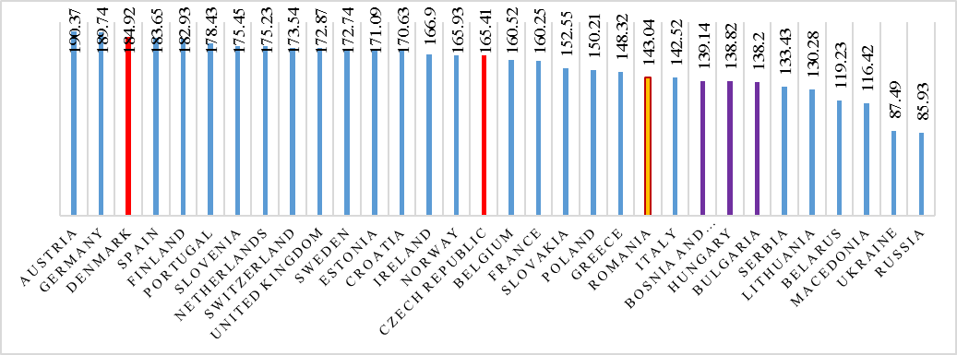

Source: https://www.numbeo.com/quality-of-life/rankings_by_country.jsp?title=2017&region=150

We start the research by taking into consideration three types of countries: countries which have their currency pegged into Euro and they are member of European Union (Bulgaria and Denmark); countries which have their currency pegged into Euro but they are still not member of European Union (Bosnia and Herzegovina); and, countries which are member of European Union but they don’t have their currency pegged into Euro or any other international currency (Czech Republic, Hungary, Romania). All these countries are part of the member of Council of Europe, and except Bosnia and Herzegovina, all the other countries are member of European Union, European Economic Area and members of European Custom Union (this explain why Bosnia and Herzegovina face a lower negative current account of balance of payment, because this country is not part yet of these agreements which came with many benefits for country members).

The research revealed the following:

Countries which have their currency pegged to Euro and they are member of European Union, as a fix exchange rate regime (like Bulgaria and Denmark) are more attractive for foreign investors, this is for sure. They register low level of unemployment rate, inflation and a positive current account of balance of payment. Both countries register a smoothly economic growth and without fluctuations throughout the analysis period. However, these two countries should be treated separately from the international trade partners, economic and politic stability approach. Denmark conduct its majority international trade partners are countries from Central Europe or North European countries Denmark being part of many European agreement which have the basic scope: promote the social, economic and political stability environment. (Denmark is member of: Schengen Area, Nordic Council, NB8). All these countries have a stable monetary and financial policy and they are very open for foreign investments (Nordic countries register the higher level of investments freedom index and the highest quality of life index and the higher purchasing power index. On the other part, Bulgaria, even it is very attractive that it has home currency pegged to Euro (especially for tourism sector), the instability of political regime and a permissive finance and monetary policy, accompanied by bureaucracy make Bulgaria still struggling to strengthen investor confidence and increase foreign investments percentage, jobs and the economy in general, and this also a result of low political stability (see chart no 1.9) and high level of corruption (see chart no 1.10). From quality of life perspective, from all these 6 countries analyzed, Bulgaria register the lowest level.

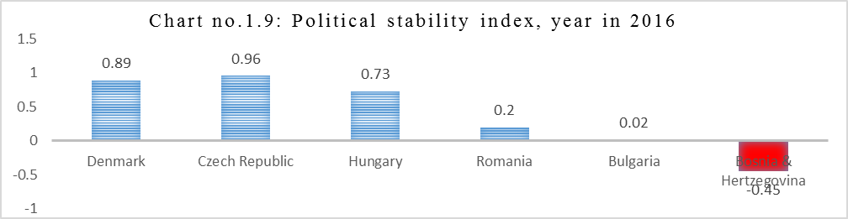

Source: based on data from http://www.theglobaleconomy.com/rankings/wb_political_stability/

Note: -2.5 weakest and 2.5 is the strongest value. Political stability = The highest value was in Liechtenstein: 1.46 points and the lowest value was in Ukraine: -1.93 points. Below is a chart for all countries where data are available for: Political stability.

Countries which have their currency pegged into Euro but they are still not member of European Union Bosnia and Herzegovina are trying to recover their economy and become member of European Union. In this moment, this country is not yet part of any European economic agreement, which make this country to face many challenges related to international trade, increasing the confidentiality of external partners, ensuring a stable economic, social and political framework, combating and diminishing the level of corruption (sea charters no.19 and no.10), attracting foreign investors, increasing the number of jobs, and the economy in general.

Countries which are member of European Union but they don’t have their currency pegged into Euro or any other international currency (Czech Republic, Hungary, Romania) are the fighters which are trying to develop themselves economically and socially and demonstrate economic and political stability towards external partners. All these countries are part of European Union, European Economic Area and members of European Custom Union, however, in plus of that: Czech Republic and Hungary are also part of economic agreement Visegrad Group; and Romania is part also of BSEC. Being part of different economic agreements and conducting their international with countries from the same region, but not quite the same, make this Czech Republic and Hungary to fallow a different trend then Romania. From economic growth, all these three countries registered positive trend, the higher annual economic growth (compare with all six countries analyzed also) was recorded by Romania (during the period 2010-2016, and reaching 5% of GDP in 2016). This higher level of economic growth was a result of economic development strategy applied starting with 2010. Foreign investment participation to GDP, in these three countries followed the same trade, increasing but fluctuating one, with better figures that the other countries. Compere with all countries analyzed, Romania recorded again the higher foreign investment percentage in GDP, however, like Hungary and Czech Republic, again not stable, because of exchange rate fluctuations. From Investment freedom index perspective, seems that Romania still face problems with bureaucracy (see chart no.1.11) and political stability. Hungary and Romania still are considered countries with high level of corruption (chart no.1.10).

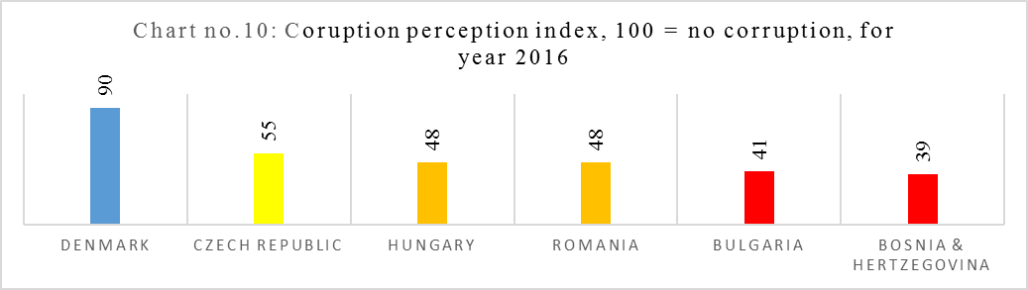

Source: based on data from http://www.theglobaleconomy.com/rankings/wb_political_stability/

Note: The average for 2016 was 59.24 points. The highest value was in Denmark: 90 points and the lowest value was in Ukraine: 29 points.

The research concluded with possible recommendations for Romania and the neighboring countries analyzed in this paper work: Hungary, Czech Republic, Bulgaria, and Bosnia and Herzegovina: a stable exchange rate, currency pegs enable importers and exporters to create a stable trading environment. They will know exactly what exchange rate to expect, limiting uncertainties like inflation or interest rates that could inhibit dealings between two countries.

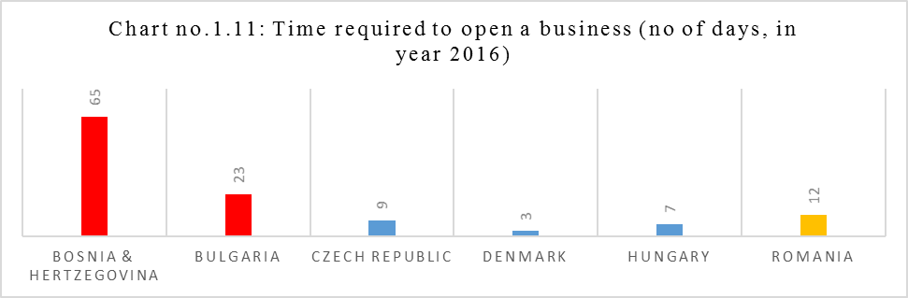
Source: based on figures from http://data.worldbank.org/indicator/IC.REG.DURS.MA

A sustainable monetary policy, promoting a stable fix exchange rate, or home currency pegged in Euro will let the government to have a clearer picture of state budget, revenue and expenditures, the exchange rate fluctuations can be avoided, international trade will be recorded more accurate. Stable and a clear picture of balance of payment, stability trade environment and a stable interest rate level will encourage the foreign investor confidence to develop and extend their businesses in West European countries. A pegged exchange rate also supports a rising standard of living and economic growth. And it protects a nation from volatile swings in the foreign exchange rate, which reduces the likelihood of a currency crisis. The biggest advantages come from the effect it has on a country’s exports and trade, especially between a country with low production costs and another country with a stronger currency. An economically developed country may choose to produce its goods in a country less developed, where production costs are smaller. When those less developed countries translate their earnings into their domestic currencies, they make a larger profit, creating a win/win situation for both countries. However, the monetary policy related to fixing the exchange rate regime should be accompanied with a strong policy against fraud, and one of the first steps could be creating a stable and clear financial, avoiding the bureaucracy and eliminating corruption.

REFERENCES

Ala El Alami, A Study on a Currency peg in the GCC Region with a Special Focus on UAE and its Impact on Economic Development, The British University in Dubai, Dissertation Paper, 2013, http://bspace.buid.ac.ae/bitstream/1234/373/1/110040%20-%20Dissertation.pdf

Coudert, V., Couharde, C., Mignon, M., Pegging emerging currencies in the face of dollar swings, Centre D’Etudes Prospectives et D’Informations Internationales, No.21, 2012, http://www.cepii.fr/pdf_pub/wp/2012/wp2012-21.pdf

Codogno L., De Grauwe P., Why Denmark should either abandon its peg to the euro or join the single currency,
http://blogs.lse.ac.uk/europpblog/2015/03/12/why-denmark-should-either-abandon-its-peg-to-the-euro-or-join-the-single-currency/ , 2015

Kimberly A., What Is a Peg to the Dollar?, Why Countries "Peg" Their Currency to the Dollar, 2016, https://www.thebalance.com/what-is-a-peg-to-the-dollar-3305925

Madura J., International Financial Management, 13th ed., CengageBrain, ISBN-13:978-1-337-09973-8

Yevchenko, N.N., Currency Transactions and Customs Flows in the Foreign Economic Relations of a Region, Studies on Russian Economic Development, 2010

https://www.cia.gov/library/publications/the-world-factbook/

https://www.currencyfair.com/blog/pegged-currency-affect-exchange-rates/

https://www.imf.org/external/pubs/ft/weo/2016/01/weodata/index.aspx

https://data.oecd.org/denmark.htm

http://www.theglobaleconomy.com

http://data.worldbank.org/country

http://www.tradingeconomics.com

http://www.investopedia.com/terms/c/currency-peg.asp

https://en.wikipedia.org/wiki/Fixed_exchange-rate_system

https://ycharts.com/indicators

http://ec.europa.eu/eurostat

Correspondence: Dr. Narcisa Roxana Mosteanu, Associate Professor at American University in the Emirates, College of Business Administration, United Arab Emirates, Dubai, Dubai International Academic City, UAE, PO Box 503000, email: narcisamosteanu@yahoo.com or m.narci@yahoo.com
Euro is a common currency used in 19 countries from Europe (majority members of European Union). Monetary policy for Eurozone (countries where is used Euro as home currency) is conducted by the European Central Bank which control the supply of this money.
Values are expressed in EURO after using the exchange rate from http://appsso.eurostat.ec.europa.eu/nui/show.do?dataset=ert_bil_eur_a&lang=en
? Why Bosnia has the world's highest youth unemployment rate, Velma Saric and Elizabeth D. Herman, https://www.pri.org/stories/2014-10-09/why-bosnia-has-worlds-highest-youth-unemployment-rate
The Council of Europe (CoE) is an international organization whose stated aim is to uphold human rights, democracy, rule of law in Europe and promote European culture. The organization is distinct from the 28-nation European Union. The best known body of the Council of Europe is the European Court of Human Rights.
The European Union Customs Union (EUCU) is a customs union which consists of all the member states of the European Union. No customs duties are levied on goods travelling within the customs union and—unlike a free trade area—members of the customs union impose a common external tariff on all goods entering the union.
Nordic Council includes the following countries: Denmark, Finland, Iceland, Norway, and Sweden. Nordic Council promote the cooperation (economic, social and politic) between members.
Nordic-Baltic Eight (NB8) is a regional co-operation format that includes Denmark, Estonia, Finland, Iceland, Latvia, Lithuania, Norway, and Sweden.
http://www.theglobaleconomy.com/rankings/herit_investment_freedom/
https://www.numbeo.com/quality-of-life/rankings_by_country.jsp?title=2017&region=150 https://www.numbeo.com/quality-of-life/rankings_by_country.jsp
https://www.numbeo.com/quality-of-life/rankings_by_country.jsp?title=2017&region=150
The Visegrad Group, also called the Visegrad Four, or V4 is a cultural and political alliance of four Central European states – Czech Republic, Hungary, Poland and Slovakia – for the purposes of furthering their European integration, as well as for advancing military, economic and energy cooperation with one another (https://en.wikipedia.org/wiki/Visegr%C3%A1d_Group )
The Organization of the Black Sea Economic Cooperation (BSEC) is a regional international organization focusing on multilateral political and economic initiatives aimed at fostering cooperation, peace, stability and prosperity in the Black Sea region. State members: Albania, Armenia, Azerbaijan, Bulgaria, Georgia, Greece, Moldova, Romania, Russia, Serbia, Turkey, Ukraine. Observer nations: Austria, Belarus, Croatia, Czech Republic, Egypt, France, Germany, Israel, Italy, Kazakhstan, Poland, Slovakia, Tunisia, USA. (https://en.wikipedia.org/wiki/Organization_of_the_Black_Sea_Economic_Cooperation )

